February 5, 2024
1st Grade:

Lesson 9-3: Is there ~ ? Are there ~ ? (pages 116-117)

Activity Name:  Find The Box | Mechanics:  - The class will be divided into pairs.  - Each student will receive a worksheet.  - Student A will secretly choose a box from 1-25.  - Student B will try to guess Student A’s box, by asking questions about the box.  Is there a (dog / panda / cat / rabbit / lion) in the box ?  Are there many (strawberries / grapes / oranges / watermelons / bananas) in the box ?  - For each question of Student B, Student A to respond with Yes, there is. / Yes, there are.  No, there isn’t. / No, there aren’t.  - By process of elimination, Student B to make a guess of Student A’s box from 1-25.  - After Student B guesses correctly, they exchange roles.
Target Language Skill:
Speaking, Writing
Topic/Theme:
Is / Are there ____ ?
Materials:
Worksheet, pencils
Mode:
By Pair
Estimated Time:
25 minutes

5 minutes – Instructions
10 minutes – Game
10 minutes - Writing

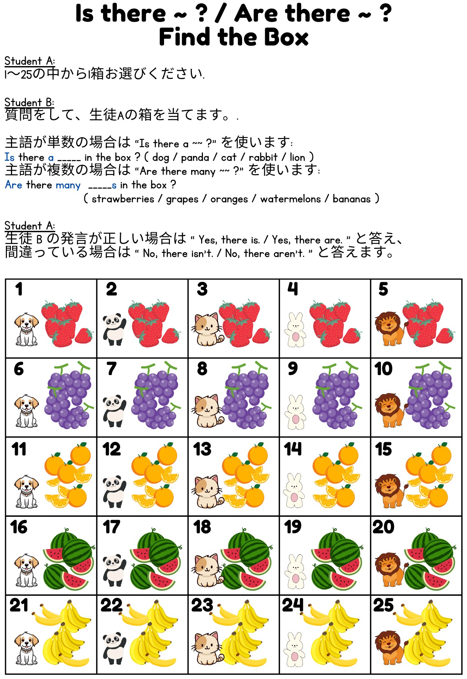

Name: _______________________________________________

Find The Box

主語が単数の場合は ~~ を使います:
Is there a _____ in the box ? ( dog / panda / cat / rabbit / lion )
主語が複数の場合は ~~ を使います:
Are there many _____s in the box ?
( strawberries / grapes / oranges / watermelons / bananas )

Write 2 questions about your partner’s Box:
パートナーのボックスについて 2 つの質問を書きます。

___________________________________________________________

___________________________________________________________

Write 4 answers about your Box:
あなたのボックスについて 4 つの回答を書いてください:
___________________________________________________________

___________________________________________________________

___________________________________________________________

___________________________________________________________

