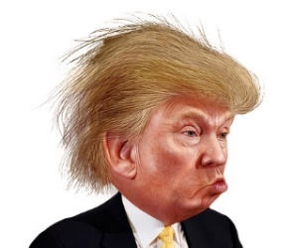
Name: ___________ Class: ____ Number: ____ Date: ___/____
ELECTION USA
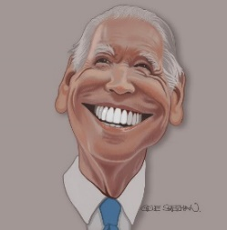

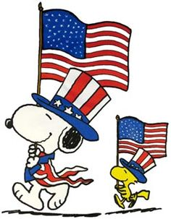

plays | eats | wears | drinks
makes | swims | sings | writes
cooks | runs | uses

notes | a song | dinner | cookies
coffee | fast | cool | a computer

- _______________________________________
- _______________________________________
- _______________________________________
- _______________________________________
- _______________________________________
- _______________________________________
- _______________________________________
- _______________________________________
- _______________________________________
- ______________________________________
- _______________________________________
- ______________________________________
Example
- Who dances?
- Who eats burgers?
QUESTIONS
- Who plays tennis?
- Who drinks coffee?
- Who uses a computer?
- Who cooks dinner?
- Who sings a song?
- Who writes notes?
- Who makes cookies?
- Who plays basketball?
- Who runs fast?
- Who eats ice cream?
- Who wears a cool hat?
- Who swims fast?

