

**Question:**

What did you eat for dinner last night?

**Question:**

What song do you like?

**Question:**

What game do you like?

**Question:**

Do you like ski or snowboard?

**Question:**

What can you do?

**Question:**

What are you good at?

**Question:**

Where is your ALT from?

**Question:**

When is your birthday?



**Question:**

What time is it now?

**Question:**

What is your favourite subject?

**Question:**

What is your name?

**Question:**

What anime do you like?





**Question:**

What time did you get up today?

**Question:**

What did you do last weekend?

**Question:**

What is your favourite season?

**Question:**

What is the date today?



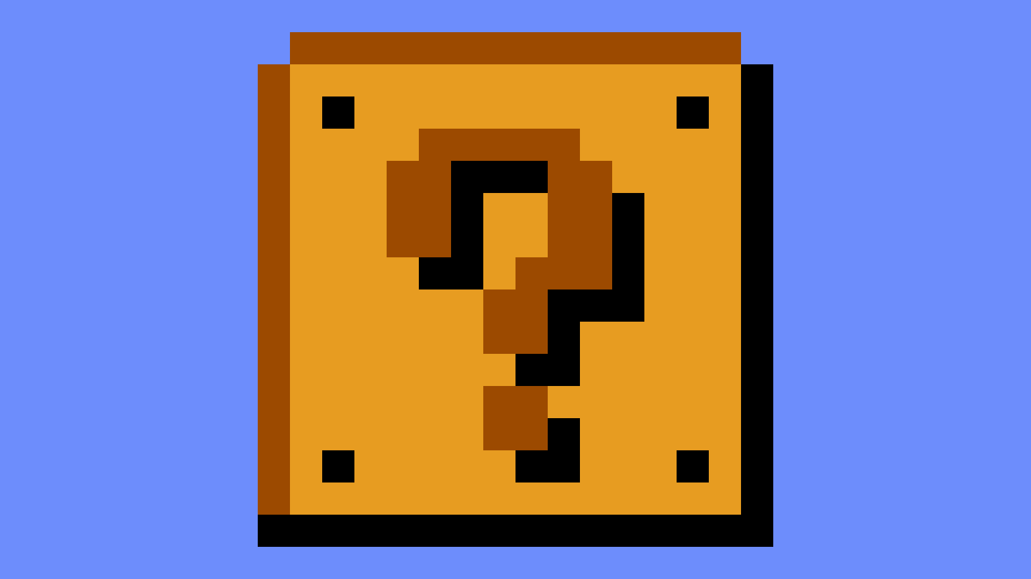



**Go up**

**one row**

**Go up**

**one row**

**Question:**

How's the weather?

**Question:**

How are you?

**BOO**

Take an item from a player!

**BLUE SHELL**

1st person lose a turn and items

**BLUE SHELL**

1st person lose a turn and items

**BANANA**

Put wagomu on your space.

Hit player lose a turn.

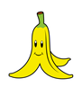

**BOO**

Take an item from a player!

**BANANA**

Put wagomu on your space.

Hit player lose a turn.

**FREEZE**

Freeze a player for

1 turn

**FREEZE**

Freeze a player for

1 turn

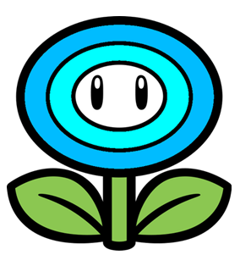



**LOSE A TURN**

**LOSE A TURN**

**LOSE A TURN**

**LOSE A TURN**





**Question:**

Did you cook dinner last night?

**Question:**

Do you like dancing?

**Question:**

Do you like reading books?

**Question:**

Can you ski?

**Question:**

Can you play the piano?

**Question:**

**Question:**

**Question:**

**Question:**

What time is it?

**Question:**

**Question:**

**Question:**

Did you watch anime yesterday?

**Question:**

What time did you get up today?

**Question:**

**Question:**

**Question:**

Did you ride a bike

to school today?





