Name: _____________ Class: ____ Number: ____
Let’s Talk 6

Can you repeat your name?
A: Ring ring
B: Hello?
A: Hello, this is Robert. Is Hank in?
Hello?
B: I’m sorry. He isn’t home yet.
A: I see. Will you give him a message, please?
B: Of course. What is it?
A: The party will start at 7:00pm.
B: I see. I’ll tell him.
Once more please
A: Thank you.

From | For | Message
Robert | Hank | The party will start at 7:00

NUMBER ONE
TELEPHONE TALKS
A: Ring ring.
B: Hello.
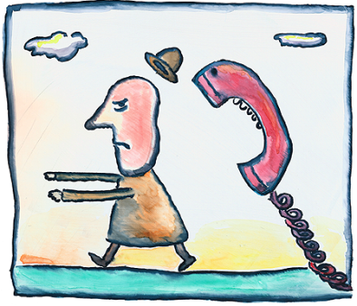
A: Hello this is . Is in?
B: I’m sorry. isn’t home yet.
A: I see. Will you give a message, please?
B: Of course. What is it?
A:
B: I see. I’ll tell .
A: Thank you.

NUMBER TWO
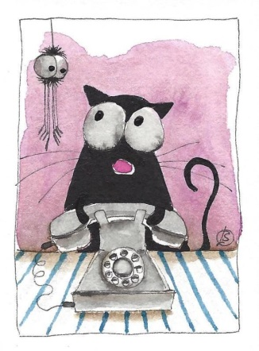
A: Ring ring.
B: Hello.
A: Hello this is . Is in?
B: I’m sorry. isn’t home yet.
A: I see. Will you give a message, please?
B: Of course. What is it?
A:
B: I see. I’ll tell .
A: Thank you.

NUMBER THREE
A: Ring ring.
B: Hello.
A: Hello this is . Is in?
B: I’m sorry. isn’t home yet.
A: I see. Will you give a message, please?
B: Of course. What is it?
A:
B: I see. I’ll tell .
A: Thank you.
Ryu-Akiko: There is an English test tomorrow.

Akihiro-Hiroyuki: The basketball game will be in Nagaoka.

Yuka-Kenji: I can’t watch the movie on Saturday.

Makiko-Rina: We will ski in Suhara on Sunday.

Mari-Makiko: The club will start at 8am on Saturday.

Kumi-Ichiro: Doraemon will visit our school tomorrow.

Mr. Tanaka-Yoshiko: You must finish your homework by Friday.

Ryusuke-Arisa: There is no school tomorrow.

