Unit 5 Part 3 (page 60-61)
Pronouns (代名詞)
Subject pronouns  主語のとき（～は、～が） | Object pronouns  目的語のとき（～を、～に） | Possessive pronouns  所有を表すとき（～の）
I | me | my
you | you | your
he | him | his
she | her | her
it | it | its
we | us | our
they | them | their
Do you know him? What is his name?
あなたは 彼を 知っていますか？ 彼の 名前は何ですか。

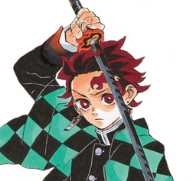
This is Kamado Tanjiro.
He is a boy.
His clothes are cool.
Do you like him?

This is Anya Forger.
( ) likes peanuts.
( ) hair is pink.
Do ( ) know ( )?
This is BTS.
( ) are a K-pop band.
( ) songs are great.
I like ( ).

Please introduce us to someone (or a group) you like!
Please use AT LEAST one subject pronoun, one object pronoun and one possessive pronoun.

