Hi, how are you?

I’m fine, thanks, and you?

I’m good, thanks.

What do you do in your free time?

Hmmmm. I play games. I like fighting games.

Cool. I like games too. I like puzzle games.

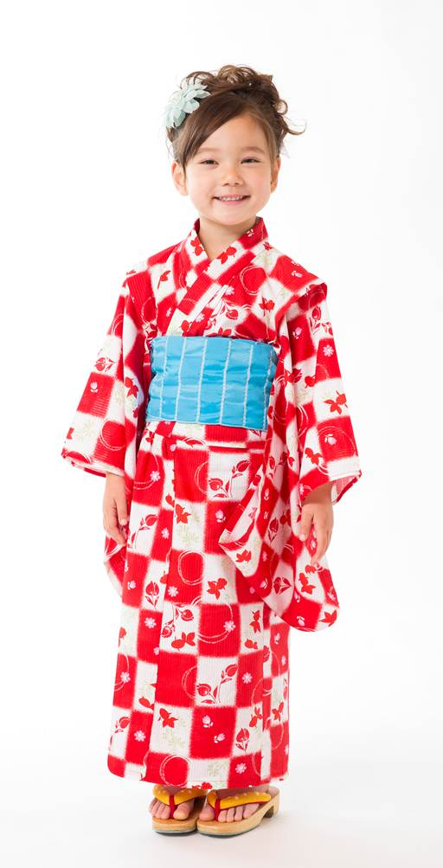
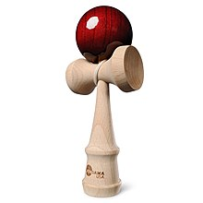
Nice! What puzzle game do you like?

I like tetris. It is exciting.

What do you do on Sundays?

I go to Harashin. I like the bakery.

