Hi, how are you?

I’m fine, thanks, and you?

I’m good, thanks.

I think TV is better than games. There are many great programs.

Really? I think games are better. You can play with friends.

Good idea. I like TV. It is relaxing.

I like games. They are exciting.

Cool. How about movies or TV? Summer or winter?

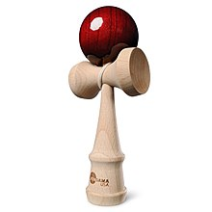
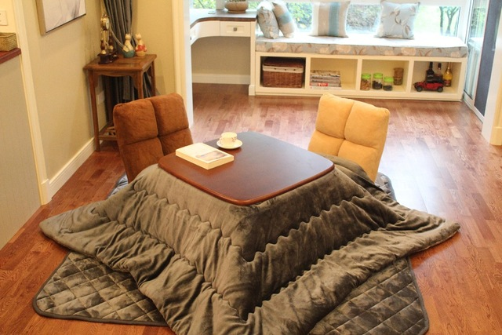
Big cities or small towns? Sports or games? English or math?

