Name: ______________ Class: ______ Number: _____
OUR PARK (add 10 details)
in the sky  in the forest  in the front  on a lily pad | on the grass  on the log  near the fence  in the center | on the fence  in the pond  on the left  on the right
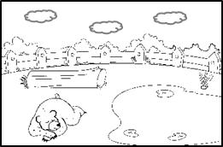
There are three clouds flying in the sky.
There is a bear sleeping on the grass.
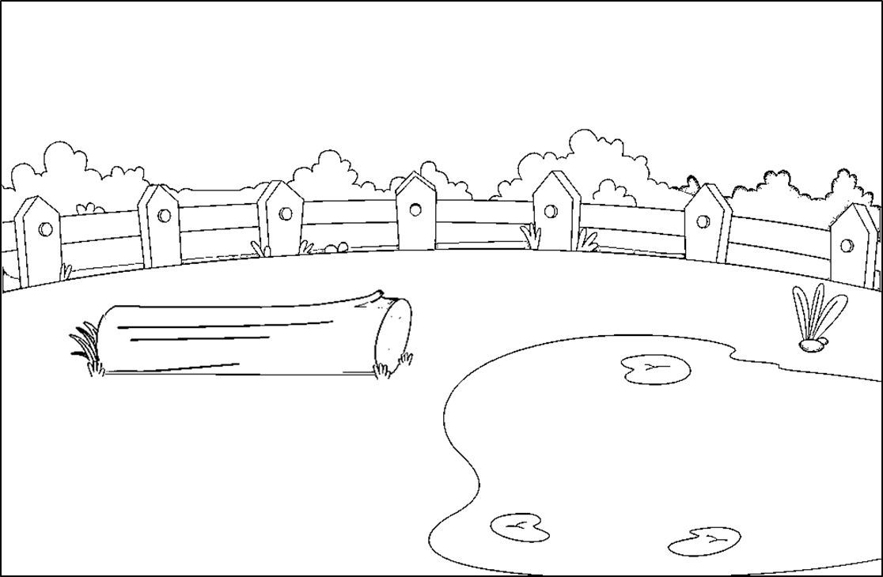

WRITE ABOUT YOUR PICTURE
- ___________________________________________________
- ___________________________________________________
- ___________________________________________________
- ___________________________________________________

