Name: _____________ Class: ___ Number: ___ Date: __/__

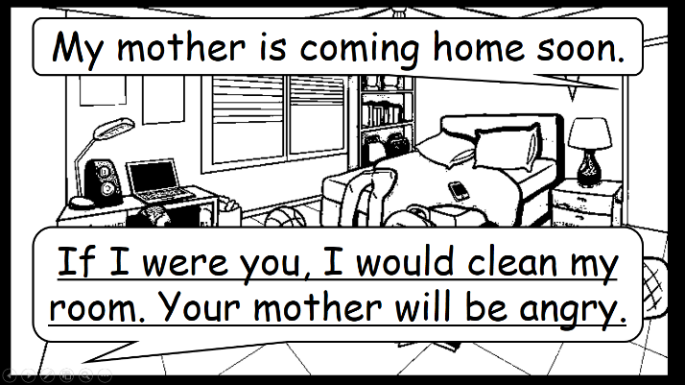

If I were a…, I would...

If I were you, I would...

I have a big test next week.



_________________________________________________

_________________________________________________

I want to be a famous musician.

________________________________________________

________________________________________________



I want to be a superhero.

I lost my dog.

________________________________________________

________________________________________________

_________________________________________________

_________________________________________________

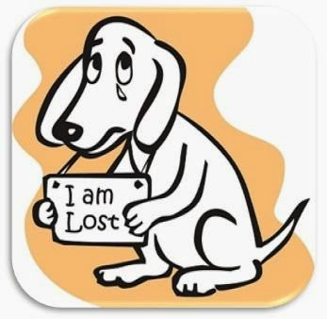

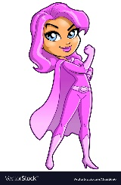

_________________________________________________

_________________________________________________

________________________________________________

________________________________________________

I will go to New York soon.

I want to be a cat.



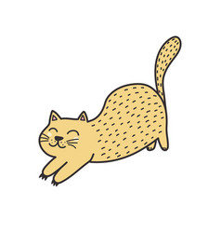

I have a big match soon.

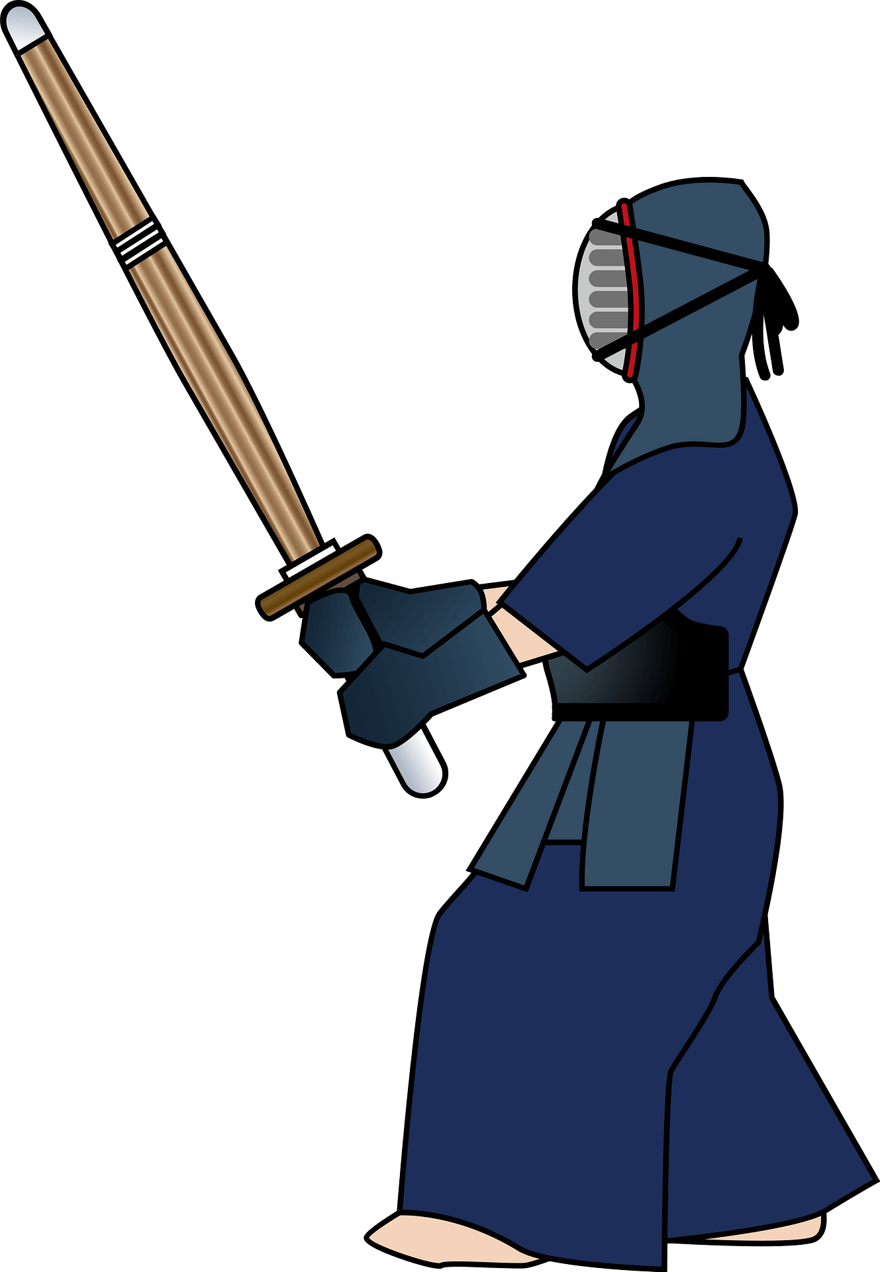

_________________________________________________

_________________________________________________

I want to be a bird.

________________________________________________

________________________________________________

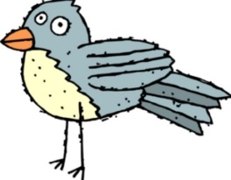

I have a broken heart.

________________________________________________

________________________________________________

_________________________________________________

_________________________________________________



I want to be a dolphin.



_________________________________________________

_________________________________________________

________________________________________________

________________________________________________

________________________________________________

________________________________________________