What’s in the park?
1
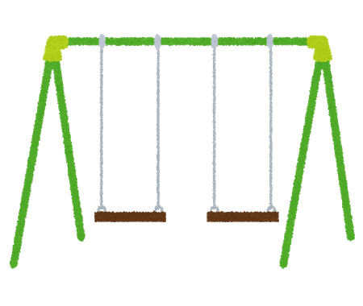
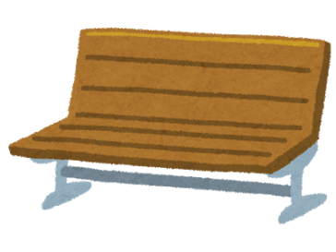
3
2
6
5
4

単数 – is | boy | cat | newspaper | onigiri | soccer ball
複数 – are | girls | dogs | birds | flowers | bikes
- 聞き方: Is there a boy in the park? 1) 聞き方: Are there girls in the park?
- 聞き方: Is the boy on the swings? 2) 聞き方: Are the girls by the bench?
Round 1:
- There ______________________ in the tree.
- There ______________________ by the swings.
- There ______________________ on the swings.
- There ______________________ under the bench.
- There ______________________ on the bench.
- There ______________________ by the bench.
Round 2:
- There ______________________ in the tree.
- There ______________________ by the swings.
- There ______________________ on the swings.
- There ______________________ under the bench.
- There ______________________ on the bench.
- There ______________________ by the bench.
Round 3:
- There ______________________ in the tree.
- There ______________________ by the swings.
- There ______________________ on the swings.
- There ______________________ under the bench.
- There ______________________ on the bench.
- There ______________________ by the bench.

