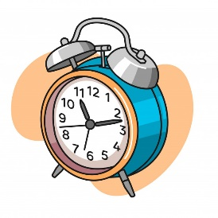
Are you HANA? “A day in my life” / What time do you~?
何時に「～」しますか。
 | Riku  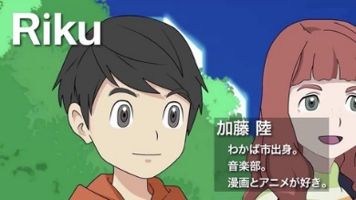 | Hana | Kate | Mark | Jing
- What time do you  get up? | At 8am. | At 7am. | At 7am. | At 8am. | At 7am.
- What time do you  study? | At 5pm. | At 7pm. | At 5pm. | At 7pm. | At 7pm.
- What time do you  eat lunch? | At 1pm. | At 12pm. | At 1pm. | At 1pm. | At 12pm.
- What time do you  watch TV? | At 8pm. | At 9pm. | At 9pm. | At 9pm. | At 8pm.
- What time do you  eat dinner? | At 6pm. | At 6pm. | At 8pm. | At 8pm. | At 6pm.
- What time do you  go to bed? | At 11pm. | At 11pm. | At 10pm. | At 10pm. | At 10pm.
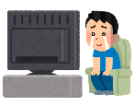
Are you ___________________________?
[Yes, I am. / No, I’m not.]
～さんですか？
Name ( ) Class ( ) No ( )

