Name: __________________ Class: _________ Number: ________



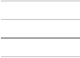BATTLE ONE

sk

1. 2. 3. 4. 5.





st



BATTLE TWO

fl

1. 2. 3. 4. 5.



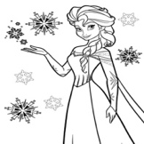

fr



BATTLE THREE

1. 2. 3. 4. 5. 5.

oo

ea