WHY? WHY? WHY?
Why do you like Nintendo?
Name: _______________ Class: ______ Number: ___ Date: ___/___
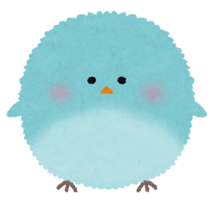
- What do you do in your free time?
Because they have good games
I _______ ___________. ( games / TV / books)
_____ is your favorite ___________? (Who / What)
It’s _________________. ( Fortnite / ItteQ / Harry Potter )
Why do you like _____________? ( it / them )
Because it _____ ___________. ( exciting / good characters)
Why do you like Hello Kitty?
Because she is cute.
- What do you do in your free time?
I ________ ___________. ( cookies / movies )
What _____ your favorite ________? ( is / are )
______ _______________. ( chocolate chip cookies / Star Wars )
Why do you like _______? ( it / them )
Because ____ ____ ___________. ( delicious / exciting / cool battles)
Why do you like English?
- What do you do in your free time?
Because Robert is cool.
I ________ ___________. ( study / listen to )
______ is your favorite ________? ( who / what )
It’s _______________. ( Namie Amuro / Michael Jackson / Robert )
Why do you like _______? ( her / him )
Because ____ has a beautiful _________. ( voice / face )
LET’S TALK WITH ROBERT

LET’S TALK WITH ROBERT

MODEL CONVERSATION ONE
Hello, how are you?
I’m fine thanks. And you?
I’m good. So, what do you do in your free time?
I play sports.
Nice. What is your favorite sport?
I like soccer.
Cool. Why do you like it?
Because it is exciting.

