Name: _____________ Class: ___ Number: ___ Date: __/__

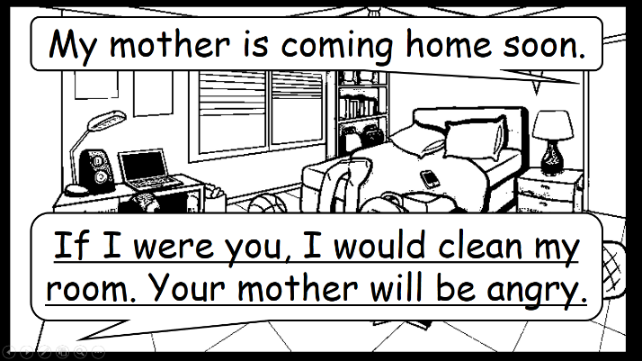

If I were a…, I would...

If I were you, I would...

I have a big test next week.

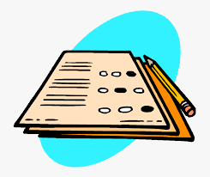

If I were you, _____________________________________

_________________________________________________

I want to be a famous musician.

If I were a famous musician, __________________________

________________________________________________

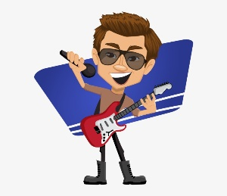

I want to be a superhero.

I lost my dog.

If I were a superhero, _______________________________

________________________________________________

If I were you, ______________________________________

_________________________________________________

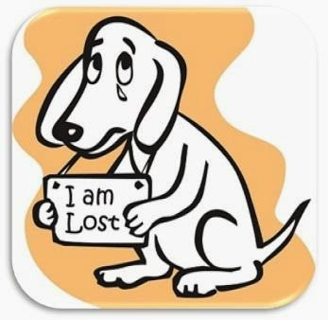

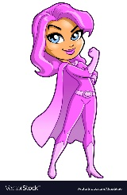

If I were you, ______________________________________

_________________________________________________

If I were a cat, ____________________________________

________________________________________________

I will go to New York soon.

I want to be a cat.



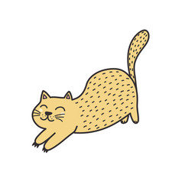

I have a big match soon.

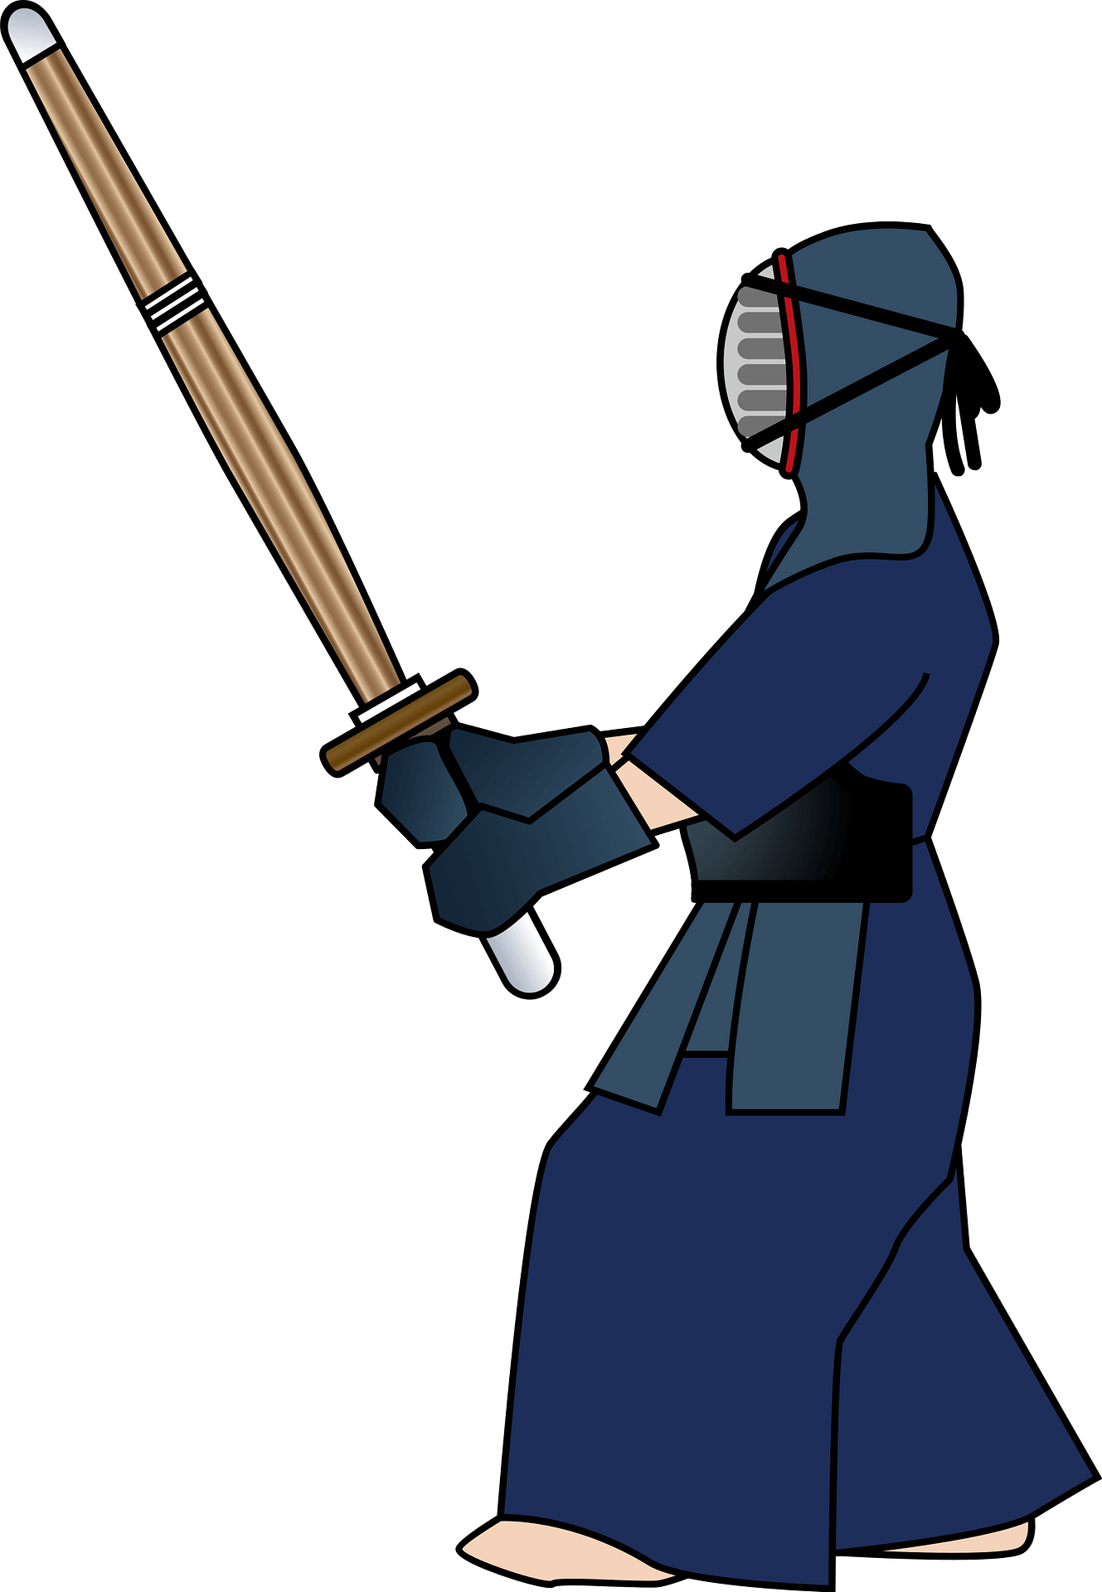

If I were you, ______________________________________

_________________________________________________

I want to be a bird.

If I were a bird, ___________________________________

________________________________________________

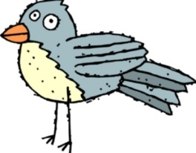

I have a broken heart.

If I were a dolphin, _________________________________

________________________________________________

If I were you, ______________________________________

_________________________________________________

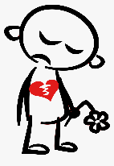

I want to be a dolphin.













