Guess the Animal!
Instructions:
- Choose an Animal and put your name by the picture. Do not show the others!
- Try to guess which animal the other students have chosen by asking “Can you… / Do you…” questions. You have 3 tries! Students should respond with “Yes, I can/ Yes, I do” if the answer is correct or answer “No, I can’t/ No, I don’t”, if the answer is no.
- At the end of three tries the student must guess the answer by asking “Are you…”.
- If they guess correctly, the student must let their partner initial their worksheet. The student with the most initials wins the game.
DOG  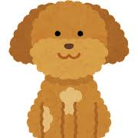 | BIRD  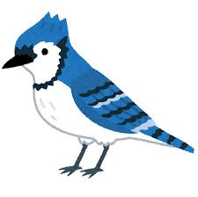 | CAT  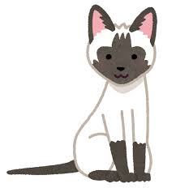
FISH  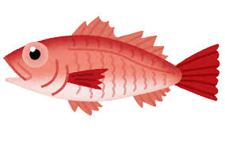 | FROG  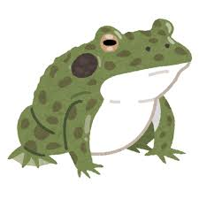 | PANDA

SCORE CARD- Put Initials here.

