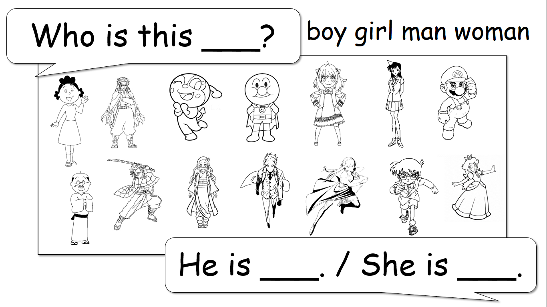
Name: ________________ Class: ___ Number: ___ Date: __/__

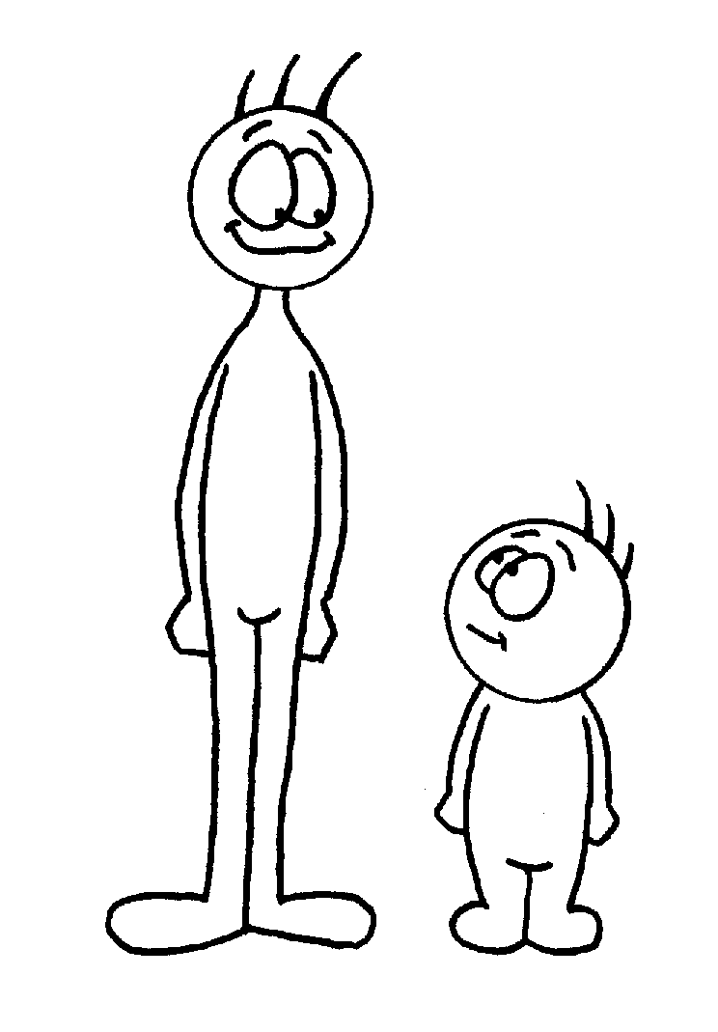
He is ~ / She is ~

cute | handsome | short | fast
dangerous | smart | tall | weak
funny | strong | scary | slow
例: He is tall.
- ______________________ | 5. _________________________
- ______________________ | 6. _________________________
3. ______________________ | 7. _________________________
4. ______________________ | 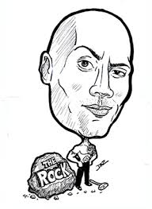  8. _________________________
is ~ isn’t Quiz

This is _________. | This is __________.
She is a __________. | He is an _________.
- She _____ from _______. | - He ___ a big _______.
2. She _____ a ______ player. | - He ____ a _______.
3. She ____ a _____ lover. | - He ____ good at _______.
WRITE A PROFILE
Name: ________________ Class: ___ Number: ___ Date: __/__
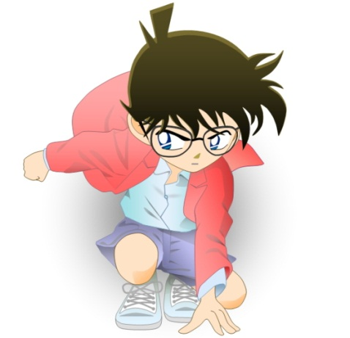
- Who is this _________?
__________________________________
__________________________________
__________________________________
__________________________________
- Who is this _________?
__________________________________
__________________________________
__________________________________
__________________________________
- Who is this _________?
__________________________________
__________________________________
__________________________________
__________________________________

