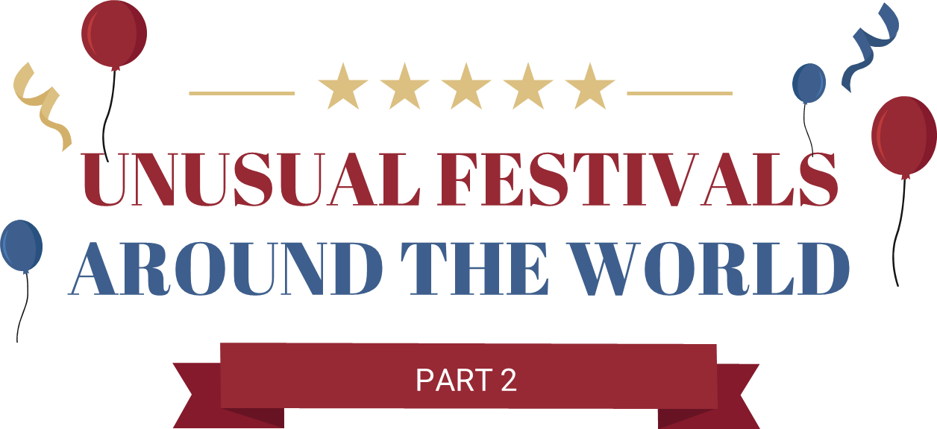
- This is a sports event festival. There are 3 events. The last sport event is _____________. The festival is from _____________.
It is called __________________________.
- This a street fair event festival. There is a king. The king is a _____________! The festival is from _____________.
It is called __________________________.
- This is the festival of colors. People _____________ the colors. The festival is from _____________.
It is called __________________________.
- This festival is a contest. People wear _____________ and throw _____________! The festival is from _____________.
It is called __________________________.
- This is a worship festival. People worship _____________!
The festival is from _____________.
It is called __________________________.
- This is a music festival. People play music _____________!
The festival is from _____________.
It is called __________________________.
- This is a hair contest festival. It is a _____________ contest.
The festival is from _____________.
It is called __________________________.
- This is a food carving festival. People carve _____________!
The festival is from _____________.
It is called __________________________.
- This is a fishing. People fish for _____________!
The festival is from _____________.
It is called __________________________.
I got __________ points out of 27.
Your Turn!
Please tell me about festivals in Japan!
