Name: ___________ Class: ____ Number: ___ Date: __/___
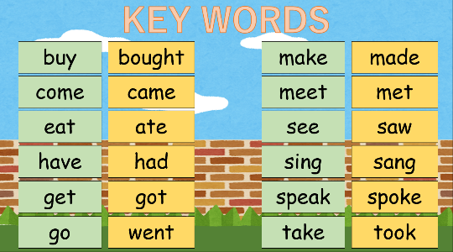
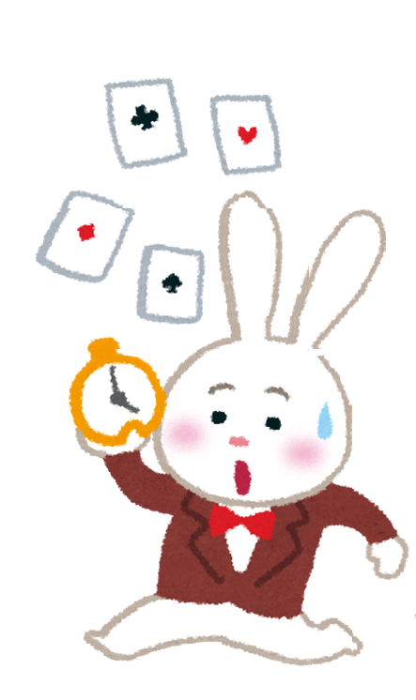
HUMPTY DUMPTY
GAME

- eat
_____________________________________________________________________
_____________________________________________________________________
- speak to
_____________________________________________________________________
_____________________________________________________________________
- go to
_____________________________________________________________________
_____________________________________________________________________
- come to school
_____________________________________________________________________
_____________________________________________________________________
- have a good time
_____________________________________________________________________
_____________________________________________________________________
- get up at
_____________________________________________________________________
_____________________________________________________________________
- buy
_____________________________________________________________________
_____________________________________________________________________
- meet ~ at school
_____________________________________________________________________
_____________________________________________________________________
- see
_____________________________________________________________________
_____________________________________________________________________
- go to bed at
_____________________________________________________________________
_____________________________________________________________________
- take a bath
_____________________________________________________________________
_____________________________________________________________________
- sing
_____________________________________________________________________
_____________________________________________________________________
- make
_____________________________________________________________________
_____________________________________________________________________
- last week
_____________________________________________________________________
_____________________________________________________________________
- last year
_____________________________________________________________________
_____________________________________________________________________
- yesterday
_____________________________________________________________________
_____________________________________________________________________
- this morning
_____________________________________________________________________
_____________________________________________________________________

