**Are you going to ～?**

Examples:

Are you going to study English tomorrow?

Are you going to Tokyo next week?

Yes, I am.

Really? Me, too.

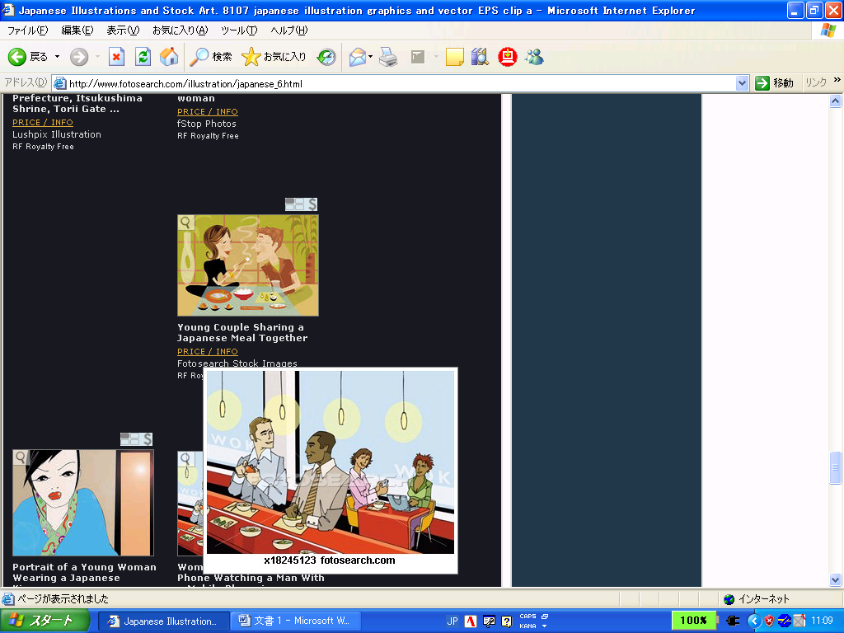

No, I’m not.

Oh, I see.

No, I am not.

Yes, I am.

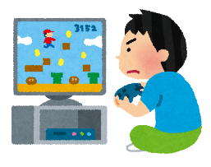

|  |  |  |  |  |  |  |  |
| --- | --- | --- | --- | --- | --- | --- | --- |
|  |  |  |  |  |  |  |  |
| do your homework? | | watch TV tonight? | | walk your dog? | | make dinner tomorrow? | |
|  |  |  |  |  |  |  |  |
| eat pizza this weekend? | | play tennis in the gym? | | buy a new pencil case? | | stay home this weekend? | |
|  |  |  |  |  |  |  |  |
| go to club activities this Saturday? | | visit Kyoto with your family? | | watch a soccer game tomorrow? | | go to the library next week? | |
|  |  |  |  |  |  |  |  |
| go to the beach on Sunday? | | go swimming with your friends? | | play video games tomorrow? | | bake a cake this Sunday? | |

**Write five (5) sentences from the bingo boxes that say ‘Yes’.**

Example: Ken is going to watch a movie tomorrow.

1. _________________________________________________________________________________

2. _________________________________________________________________________________

3. _________________________________________________________________________________

4. _________________________________________________________________________________

5. _________________________________________________________________________________

1. _________________________________________________________________________________

2. _________________________________________________________________________________

3. _________________________________________________________________________________

4. _________________________________________________________________________________

5. _________________________________________________________________________________



**Write five (5) sentences from the bingo boxes that say ‘No’.**

**Example:**  Ken is not going to watch a movie tomorrow.

