Name: ____________________  Class: ___________  Date: ___________  Peter Rabbit  If, When, That, Because | 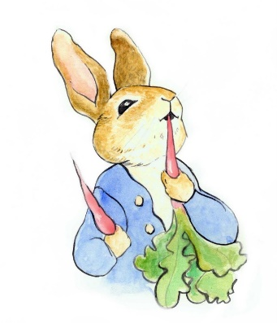

- What will you do if it’s hot? (例: If it’s hot I’ll …)
______________________________________________________________________________________________________________________________________________________________________________
--------------------------------------------------------------------------------------------------------------------------------------------------

- What do you do when you’re free? (例: When I’m free I …)
______________________________________________________________________________________________________________________________________________________________________________
--------------------------------------------------------------------------------------------------------------------------------------------------

- What do you think of AI? (例: I think that it’s …)
______________________________________________________________________________________________________________________________________________________________________________
--------------------------------------------------------------------------------------------------------------------------------------------------

- Why do you like summer? (例: I like summer because …)
______________________________________________________________________________________________________________________________________________________________________________

