Name: _________________ Class: _____ Date: _____/_____/_____

Thanksgiving Dinner Party

Read the hints to find out where each person is sitting at the table.

- The boy sitting near my grandmother is me.
- The girl talking to my brother is my sister.
- The man eating pie is my grandfather.
- The man sitting between my aunt and uncle is my dad.
- The man saying “Cheers!” is my uncle.
- The woman sitting on the left side of the table is my grandmother.
- The boy playing Rock, Paper, Scissors with me is my cousin.
- The woman drinking wine is my aunt.
- The man cutting the turkey is my dad.
- The woman sitting across from my dad is my mom.

A: | F:
B: | G:
C: | H:
D: | I:
E: | J:
E
D
C
B
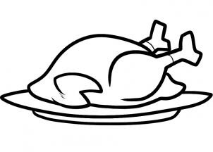
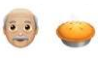
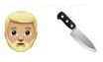
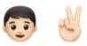
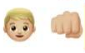
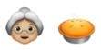
F
J
I
H
G
A

