Name:____________________________________
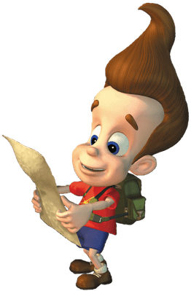
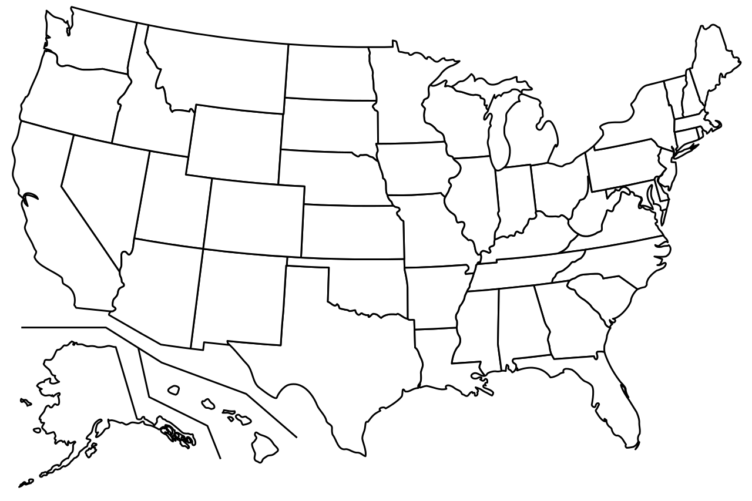
Let’s learn about the United States of America
Washington
New Hampshire
Vermont
Maine
Massachusetts
Minnesota
Montana
Oregon
- Alaska
- New York
- North Dakota
- Ohio
- Tennessee
- Texas
- Washington D.C
- Arizona
- California
- Florida
- Kansas
- Alabama
- New Mexico

Rhode Island
Michigan
Wyoming
Wisconsin
South Dakota
Idaho
Nevada
Connecticut
New Jersey
Delaware
Pennsylvania
Indiana
Iowa
Nebraska
Virginia
（ ）
Maryland
Illinois
Colorado
Utah
Kentucky
North Carolina
West Virginia
Missouri
Georgia
South Carolina
Arkansas
Oklahoma
Mississippi
Louisiana

EXAMPLE: Where can we ＿＿＿__＿ the Aurora lights? ______________________ 5. ____________ can we _________ President Biden? _________________
（会う）
（見る）
1. Where can ________ ____________ the Grand Canyon? _____________________ 6. ____________ is Halloween? ______________________
（見る）
（いつ）
2. Where can we ___________ _____ country music? _______________________ 7. ____________ ________ （ALT name）birthday? ___________________
（聴く）
（いつ）
3. Where ____________ we ___________ delicious pizza? _________________________ 8. ___________ ______ （JTE name）_____________? _________________

（いつ）
4. Where can we go to Disneyland? __________________ and ___________________. 9. ___________ is Christmas Eve? ______________________
（いつ）
Name:____________________________________
Let’s learn about the United States of America
Washington
New Hampshire
Vermont
Maine
Massachusetts
Minnesota
Montana
Oregon
- Alaska
- New York
- North Dakota
- Ohio
- Tennessee
- Texas
- Washington D.C
- Arizona
- California
- Florida
- Kansas
- Alabama
- New Mexico

Rhode Island
Michigan
Wyoming
Wisconsin
South Dakota
Idaho
Nevada
Connecticut
New Jersey
Delaware
Pennsylvania
Indiana
Iowa
Nebraska
Virginia
（ ）
Maryland
Illinois
Colorado
Utah
Kentucky
North Carolina
West Virginia
Missouri
Georgia
South Carolina
Arkansas
Oklahoma
Mississippi
Louisiana

EXAMPLE: Where can we _see_＿ the Aurora lights? __in Alaska_____________ 5. __Where__ can we __meet__ President Biden? _in Washington DC
（見る）
（会う）
1. Where can ___we_____ ___see______ the Grand Canyon? _in Arizona___ 6. ____When__ is Halloween? ___on__October 31st______
（見る）
（いつ）
2. Where can we __listen__ __to_ country music? ___in Tennessee______ 7. __When___ _is____ （ALT name）birthday? ___________________
（聴く）
（いつ）
3. Where ___can_____ we ____eat___ delicious pizza? _____in New York__________ 8. ___When__ _is__ （JTE name）_____________? _________________

（いつ）
4. Where can we go to Disneyland? _____California____ and ____Florida_________. 9. __When__ is Christmas Eve? __on __December 24th _______
（いつ）

