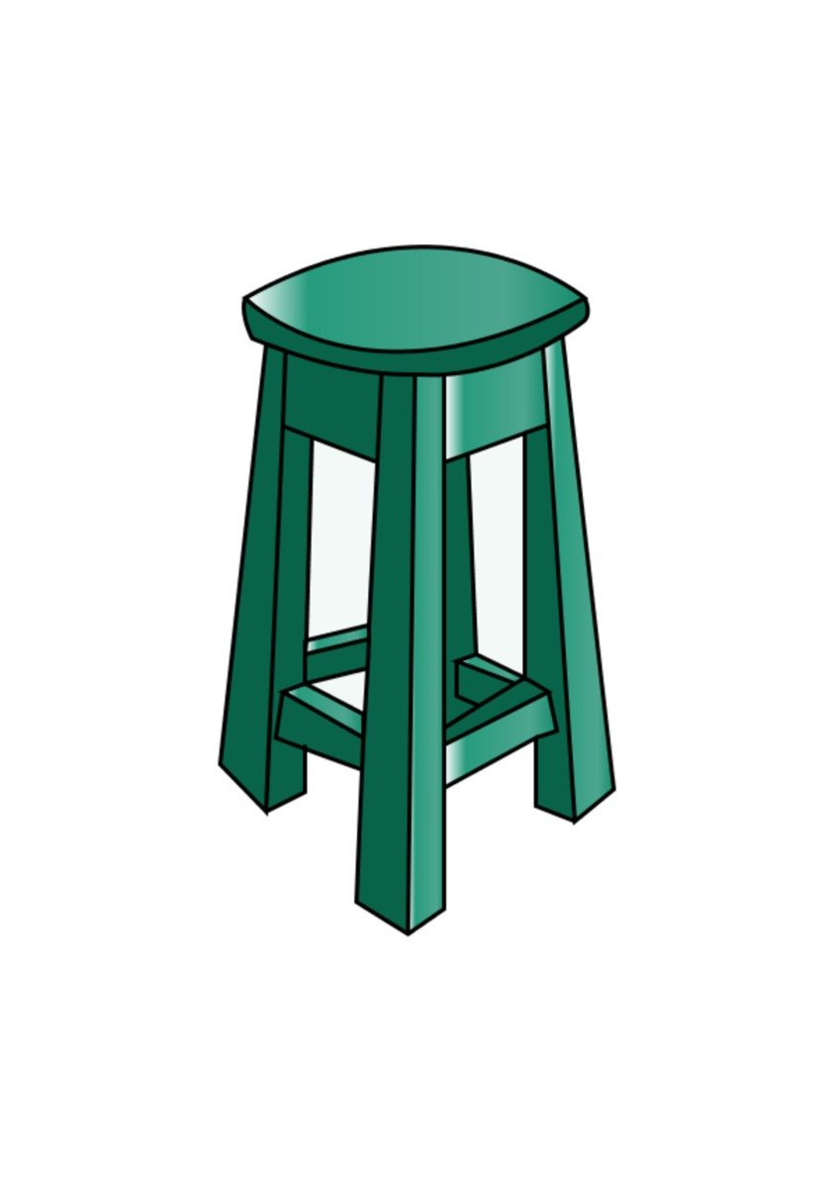**COLORS**

|  |  |  |  |  |
| --- | --- | --- | --- | --- |
| Boot Boots Shoes - Free vector graphic on Pixabay  red | blue pencil | Teaching colors, Pencil clipart, Clip art  30 Black White Classic Car Silhouettes Illustrations & Clip Art - iStockblue | Yellow Hat Clip Art at Clker.com - vector clip art online, royalty free &  public domain    yellow | green | Free Icon | Balloon | Free icons, Vector icon design, Black and white  balloons  white |
| Barbie Clipart Flower - Pink Flower Clipart - Free Transparent PNG Download  - PNGkey  black | pink | Purple Butterfly PNG Clip Art​ | Gallery Yopriceville - High-Quality Free  Images and Transparent PNG Clipart  purple | Orange Tshirt | T shirt, Clip art, Orange  orange | Free Brown Bear Clipart, Download Free Brown Bear Clipart png images, Free  ClipArts on Clipart Library  brown |