Would you do something for me?
Name: _________________ Class: ____ Number: ___
- Would you sign _____________ for me?
Yes, I’d love to.

- Would you draw a __________ for me?
Yes, certainly

- Would you _______ a message for me?
Sure, you bet.

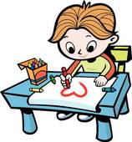
- Would you __________________ for me?
Yes, of course.

