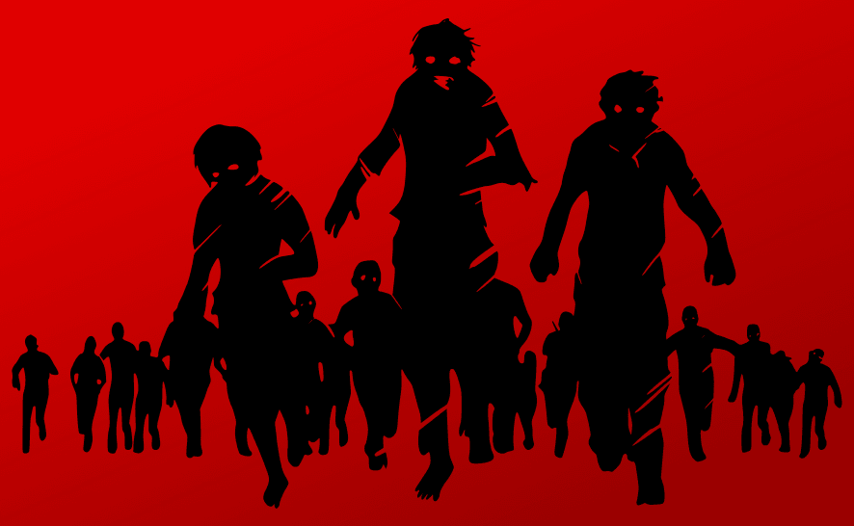
Name: ______________ Class: ______ Number: ______
ZOMBIE
ATTACK

play/plays  sing/sings  use/uses  watch/watches | have/has  read/reads  make/makes  fly/flies | teach/teaches  sleep/sleeps  work/works  drink/drinks | big  cool  cute  scary | small  strong  smart  interesting
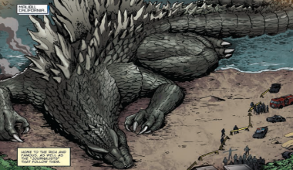
- Godzilla _______ on the beach.
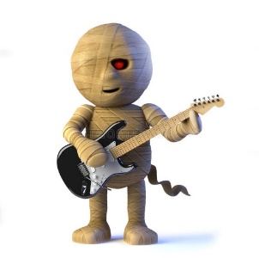
He is _______________.

- The mummy ___________________.
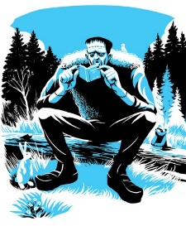
He is __________________________.

- The monster ________________________.
He _________________________________.
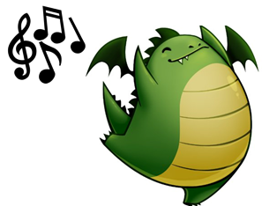
- The dragon _________________________.
It __________________________________.
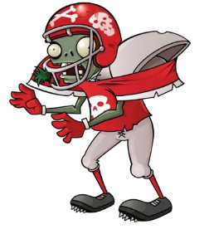
- The zombie _________________________.
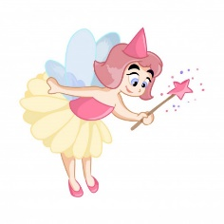
It ________________________________.

- The fairy __________________________.
She ______________________________.
- The devil _________________________.
He ______________________________.

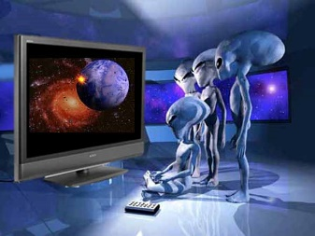
- The aliens __________________________.
They ______________________________.

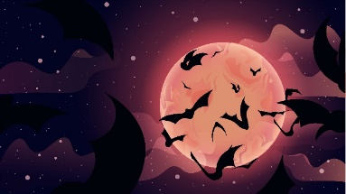
- The bats ______________________________.
They _________________________________.
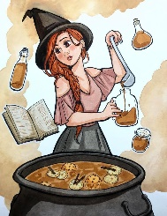
- The witch ____________________________.
_____________________________________
- The robots __________________in a factory.
____________________________________
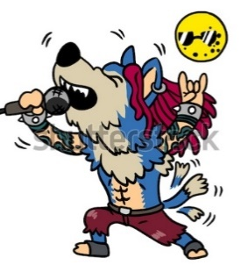
- The wolfman __________________________.
_____________________________________

- Dracula ______________________________.
_____________________________________

- The black cat ____________________________.
_______________________________________

- Our teacher _____________________________.

