I found a picture on the internet.
This is a picture I found on the internet.

Let’s play a detective game!

It’s late at night at Sanno Junior High School. It’s raining and there is a thunderstorm.
Lightning strikes!! The lights turn off.

After a little bit, the lights turn back on.
And then, Ms. Teacher Sensei screamed.

Everyone ran into the hallway. There, everyone found the lifeless body of Mateo.

Mateo has been killed.

YOU AND YOUR PARTNER have been assigned to this case.
Your mission is to find out:

Who killed Mateo?
What weapon was used?
Where did they kill him?

With your partner, find out Who, What, Where.
(Hint: The killer is someone who is alone and with a weapon)

ANSWER:
Who: Yamada
What: shovel
Where: music room

Words you might want to write on the blackboard and go over with students:

Murder Mystery

It’s late at night at Sanno Junior High School. There’s a thunderstorm. It’s raining very hard.
Lightning strikes!! The lights turn off. After a little bit, the lights turn back on.
And then, Ms. Teacher sensei screamed.
Everyone ran into the hallway. There, everyone found the lifeless body of Mateo.

Mateo has been killed.

SUSPECTS
- Suzuki
- Yamada
- Kimura
- Watanabe
- Sato
- Tanaka

WEAPONS
- gun
- knife
- baseball bat
- poison
- shovel
- banana

PLACES
- gym
- classroom
- science room
- nurse’s office
- music room
- computer room

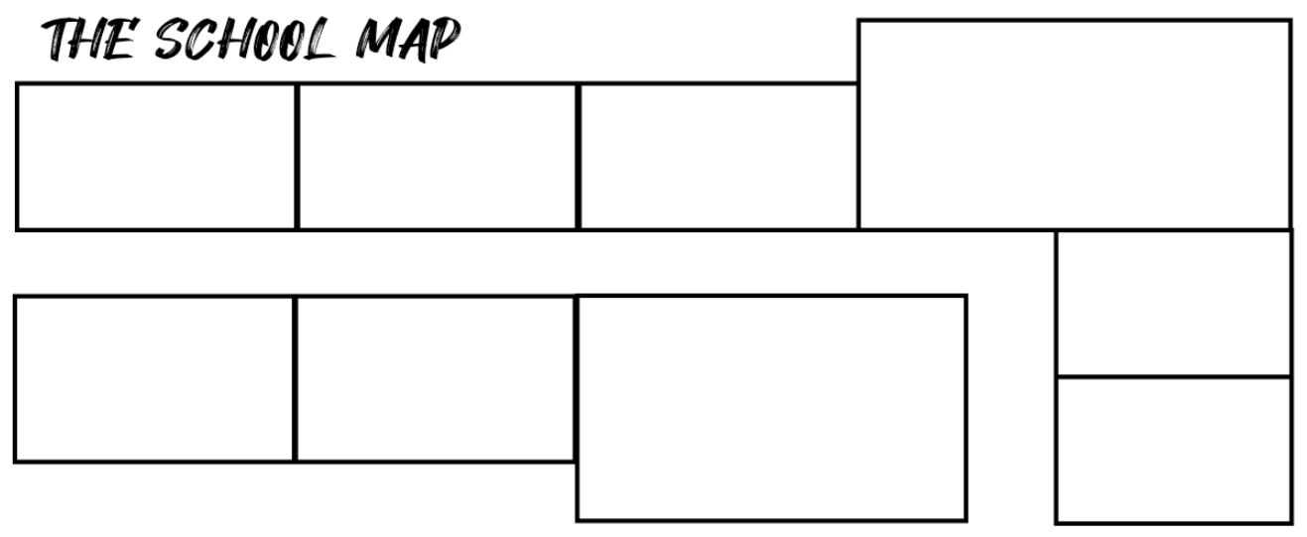
Classroom
Computer room
Nurse’s office
Gym
Science room
Music room
(Hint: The killer is someone who was alone with a weapon.)
Who?
What?
Where?

The baseball bat borrowed by Suzuki is in the gym. | Honda ate a banana he found in the computer room.
The knife was forgotten by Tanaka  in the nurse’s office. | The knife was  only used to cut boxes.
Loud music was heard in the Music room. | The weapon used by the killer was found beside a phone playing music.
No noise was heard in the classroom. | The science room is a place visited by Kimura.
The weapon the killer used is  not poison. | Poison was found in the place  Kimura visited.
Sato and Suzuki met in the place where the baseball bat was found. | The banana eaten by someone  is not dangerous.
Tanaka went home before Mateo was killed. | Tanaka saw someone alone, holding a shovel.
Watanabe saw someone go home. | The place Watanabe stayed in was  the music room.
The gun was forgotten in a quiet, empty room. | Sato and Suzuki played basketball in the gym after school.
Sato left something in the classroom. | A place students go to often  had no one in it.

1 | 2
3 | 4
5 | 6
7 | 8
9 | 10
11 | 12
13 | 14
15 | 16
17 | 18
19 | 20

