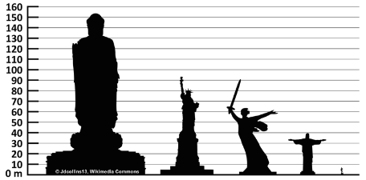
Name: ___________________ Class: ____ Number: ____
Comparative Quiz
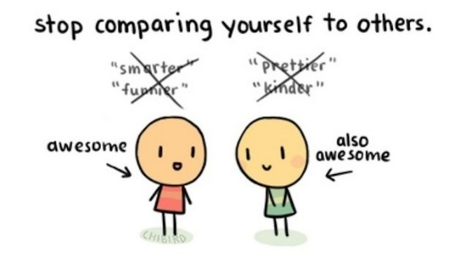
Strength= strong / stronger
Height= tall / taller
Speed= fast / faster
IQ = smart / smarter
Age = old / older
- __________________________________________________
- __________________________________________________
- __________________________________________________
- __________________________________________________
- __________________________________________________
WORD BANK
big/bigger |  | heavy/heavier |  | hard/harder |  | young/younger
small/smaller |  | light/lighter |  | soft/softer |  | new/newer
long/longer |  | hot/hotter |  | thin/thinner |  | cute/cuter
short/shorter |  | cold/colder |  | thick/thicker |  | nice/nicer
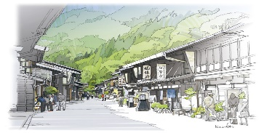
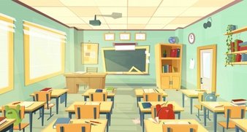
Write about your school, your town, your friends, or your home
‘The blackboard is heavier than the chalk.’
‘My father is bigger than my mother.’
- _________________________________________________________
- _________________________________________________________
- _________________________________________________________
- _________________________________________________________

