Name: _________ Class: ____ Number: ____

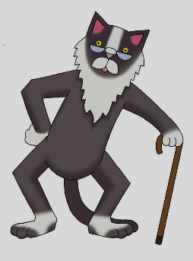

This cat is too old. Do you have a younger one?

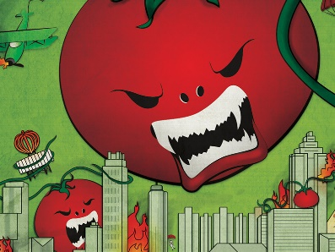

These tomatoes are too dangerous.

Do you have safer ones?

____________________

____________________

____________________

____________________

____________________

____________________

____________________

____________________

Name: _________________

**Let’s Talk 7**

**Let’s go shopping**

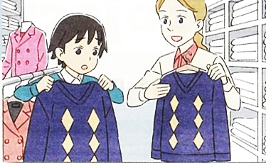

**Clerk:**  May I help you?

**Kumi:** Yes, I’m looking for ______. I want something _______.

**Clerk:** I see. How about this one / these ones?

**Kumi:** It’s / They’re okay but it’s / they’re too _____. Do you have _____?

**Clerk:** We also have this one / these ones.

**Kumi:** Perfect. I’ll take it/them.

____________

____________

____________

____________

a new dog



____________

____________

____________

new shoes



cute / cool

expensive

cheaper ones

a new bag



cheap

heavy

lighter one