I found a picture on the internet.
This is a picture I found on the internet.

Let’s do a detective game!

It’s late at night at Oak Junior High School. It’s raining and there is a thunderstorm.
Lightning strikes!! The lights turn off.

After a little bit, the lights turn back on.
And then, Ms. Yamamoto screamed.

Everyone ran into the hallway. There, everyone found the lifeless body of Kayamura.

Kayamura has been killed.

YOU AND YOUR PARTNER have been assigned to this case.
Your mission is to find out:

Who killed Kayamura?
What weapon was used?
Where did they kill him?

With your partner, find out Who, What, Where.
(Hint: The killer is someone who is alone and with a weapon)

ANSWER:
Who: Yamada
What: shovel
Where: music room

Words you might want to write on the blackboard and go over with students:
Someone = 誰か
Something = 何か
Weapon = 武器
Place = 場所
Killer = 殺人犯
left = 置いた
no one = 誰も

Murder Mystery

It’s late at night at Oak Junior High School. There’s a thunderstorm. It’s raining very hard.
Lightning strikes!! The lights turn off. After a little bit, the lights turn back on.
And then, Ms. Yamamoto screamed.
Everyone ran into the hallway. There, everyone found the lifeless body of Kayamura.

Kayamura has been killed.

SUSPECTS (容疑者)
- Suzuki
- Yamada
- Kimura
- Honda
- Sato
- Tanaka

WEAPONS (武器)
- gun
- knife
- baseball bat
- poison
- shovel
- banana

PLACES (場所)
- gym
- classroom
- science room
- nurse’s office
- music room
- computer room

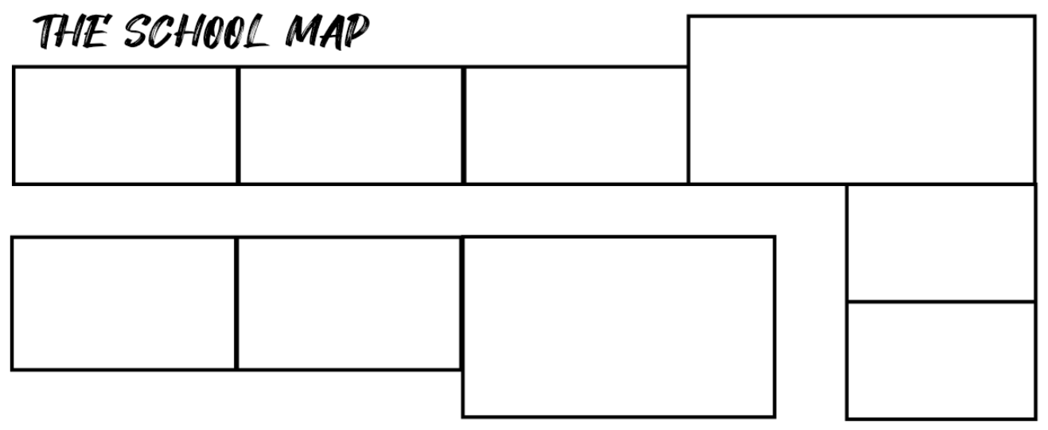
Music room
Science room
Gym
Nurse’s office
Computer room
Classroom
(Hint: The killer is someone who was alone with a weapon.)
Who?
What?
Where?

There is a baseball bat Suzuki borrowed in the gym. | Honda ate a banana he found in the computer room.
There is a knife Tanaka left  in the nurse’s office. | The knife someone left was  only used to cut boxes.
The music room is a place students go to sometimes. | The weapon the killer used is in a place students go to sometimes.
The classroom is a place students go to often. | The science room is the place Kimura visited.
The weapon the killer used is  not poison. | The poison is in the place  Kimura visited.
Sato and Suzuki met in the place the baseball bat is at. | The banana someone ate  is not dangerous.
Tanaka went home before Kayamura was killed. | Tanaka saw someone before he went home. The person he saw was holding a shovel.
Yamada saw someone go home. | The place Yamada was in is  the music room.
The gun was left in the place students go to often. | The place Sato was playing basketball is the gym.
Sato left something in the classroom. | A place students go to often  had no one in it.
1 | 2
3 | 4
5 | 6
7 | 8
9 | 10
11 | 12
13 | 14
15 | 16
17 | 18
19 | 20

