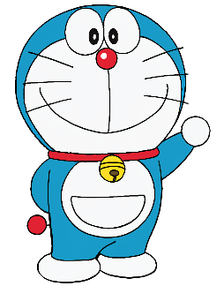

Dear my best friend

How are you? I am in the Philippines.

Yesterday, I won the singing competition here at the school. I also talked to my friends here and ate mangoes. I also joined the dance club. It was my best memory in school. The weather here is very warm. I had a very good school year here.

Please tell me about your school memories. I will wait for your letter.

Love,
Doraemon

_______________________

_______________________

___________________

___________________

Dear my best friend,
Hello! How are you?
It was raining here yesterday, and today is a sunny day. I had a fun school year here in Korea. I joined the basketball team in June. Our team did not win the championship, but it was very fun.
How was your school year? Take care of yourself.
Your friend,
Goku
_______________________

_______________________

___________________

___________________
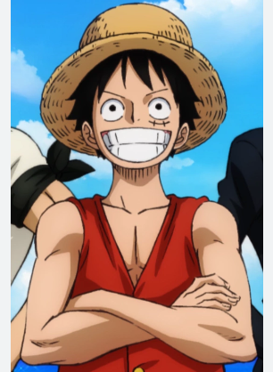
Dear my best friend,

Hi! How are you? I am very happy.
I studied very hard here in Tokyo. I learned a lot in school. My friend Zoro learned about numbers. It is a little bit cold here. Did you join the soccer club? I joined the soccer club, and we won the championship. It was a nice memory.
Please tell me about your school memories. I will wait for your letter.
Love,
Luffy
_______________________

_______________________

___________________

___________________
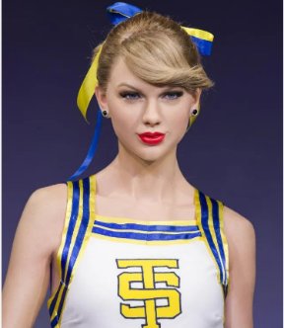
Dear my best friend,

How are you?
It is Cloudy here in America. I want to tell you about my best memory in school. My best memory is the cheer dance because it was fun. We did not win the competition but I enjoyed dancing with my friends.
I miss you. I hope to hear from you.
Love
Taylor
_______________________

_______________________

___________________

___________________
Dear my best friend,

How are you? I am fine here.
What is your best school memory this year? I learned a lot about cooking. Last night, I cooked spaghetti for my friend. He said it was delicious. Please visit me here and I will cook for you.
Take care and I miss you..
Love
Harry
_______________________

_______________________

___________________

___________________

