Name:____________________________________ Date:_______________________ Class:_________________
Not Found:
No, it was not.
No, they were not.
No, I was not.
No, he was not.
No, she was not.
Found:
Yes, it was.
Yes, they were.
Yes, I was.
Yes, he was.
Yes, she was.

Let's hunt for Easter Eggs!

You have 10 Easter Eggs. Hide them in your garden.

Draw your 10 Easter Eggs in the squares below:

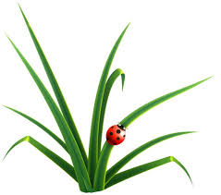  Your Garden | ...in the teacher's  room? | ...at Dekky  on  Sunday? | ...on TV yesterday? | ...with  Nobita  yesterday? | ...in  Australia  last year?
Was this cap....
Were they.....
Were you....
Was Doraemon....
Was Russell....
O = Found 1 egg X = No egg found.
Your Friend's Garden | ...in the teacher's  room? | ...at Dekky  on  Sunday? | ...on TV yesterday? | ...with  Nobita  yesterday? | ...in  Australia  last year?
Was this cap....
Were they.....
Were you....
Was Doraemon....
Was Russell....

Writing:

(Make answers from the game you played)
1. Were you at Dekky on Sunday?
________________________________________
2. Were they on TV yesterday?
________________________________________
3. Were you with Nobita yesterday?
_______________________________________
4. Was your teacher in Australia last year?
_________________________________________
5. Was the cap in the teacher's room?
__________________________________________
Make your original questions to ask 3 friends:
Question | Friend 1 | Friend 2 | Friend 3
1.
2.
3.

