Name: ___________________ Class: _____ Number: ____ Date: ___/____
2年生SMALL TALK ONE

Great!
Oh no!
Do you like sushi? | Yes, I do. / No, I don’t.
What sports do you like?  - Where do you enjoy it? | I like tennis.  - At the park.
Which do you like, games or TV?  - Why do you like them? (games)  - Why do you like it? (TV) | I like…  - Because they are fun.  - Because it is interesting.
Can you cook?  - When can you cook? | Yes, I can. / No, I can’t.  - On Saturdays and Sundays.
What did you do on Sunday?  - How was it? | I ate… / I watched… / I played… / I went to…  - It was great.
Do you have any games?  - How many games do you have? | Yes, I do. / No, I don’t.  - I have a game. / I have many games.
When is your birthday?  - What do you want? | It’s…  - I want…  Have fun!

Wow!
Nice!
Me, too!

Wow!
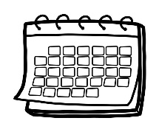 | 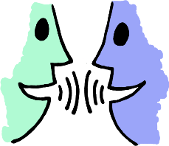 | 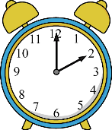 |  |  | 













