Name: ___________________ Class: _____ Number: ____ Date: ___/____
3年生SMALL TALK ONE

That sounds good!
That’s too bad!
Do you like playing sports? | Yes, I do. / No, I don’t.
What sports do you like playing?  - Where do you do it? | I like doing kendo.  - At the dojo.
Which is more interesting, games or TV?  - Why do you like them? (games)  - Why do you like it? (TV) | …is more interesting. / …are more interesting.  - Because they are fun.  - Because it is interesting.
Have you ever been to Tokyo?  - What did you do there? | Yes, I have. / No, I haven’t.  - I ate Tokyo Banana.
What did you do on Sunday?  - How was it? | I ate… / I watched… / I played… / I went to…  - It was great.
What food do you like the best?  - Why do you like it? | I like pizza the best.  - Because cheese is delicious.
What do you want to do this weekend?  - Where will you see them? | I want to see my friends.  - At school.  Have fun!

Nice!
Good luck!
Me, too!

Wow!
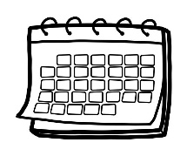 | 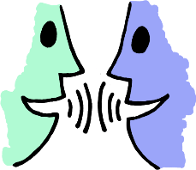 | 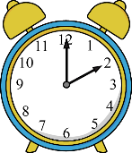 |  |  | 













