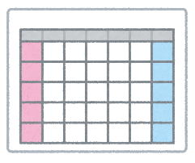
My Dream Schedule
5年―（＿＿＿＿）組（＿＿＿）番 名前：＿＿＿＿＿＿＿＿＿＿＿＿＿_______＿
I have _________, _________, _________, _________, __________, and ___________ on (曜日).
 | Mondays | Tuesdays | Wednesdays | Thursdays | Fridays
1
2
3
4
5
6 |  |  |  | Club Activity

Class: 5-(___) Student Number: (____) Name:_____________________________
Question:
What do you want to study?
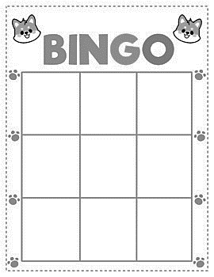
Answer:
I want to study
Why?

WORD LIST
English | Japanese | math | science
social  studies | calligraphy | P.E. | music
arts and  crafts | home economics | moral education

