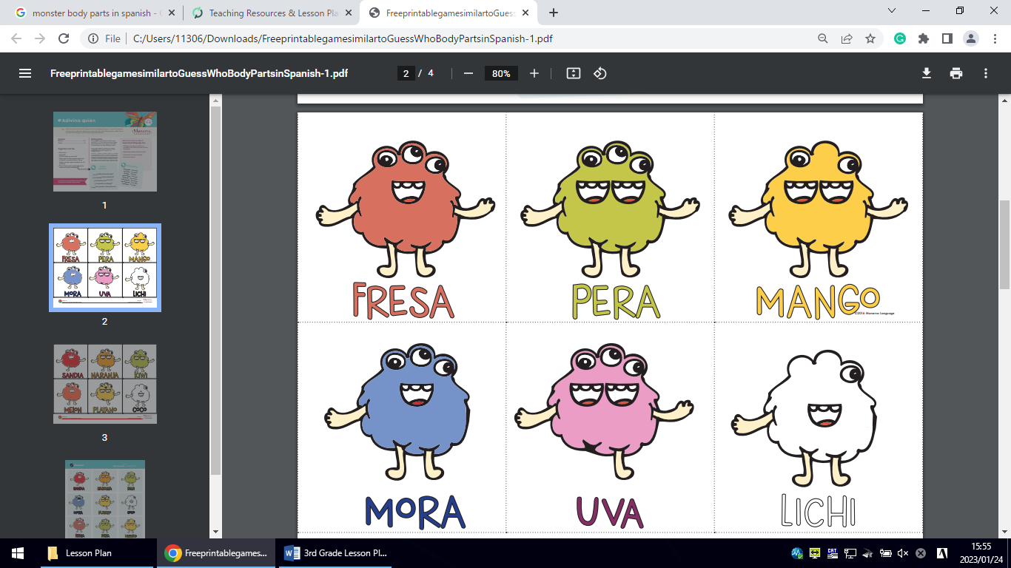

strawberry pear (梨) mango



blueberry grapes lychee

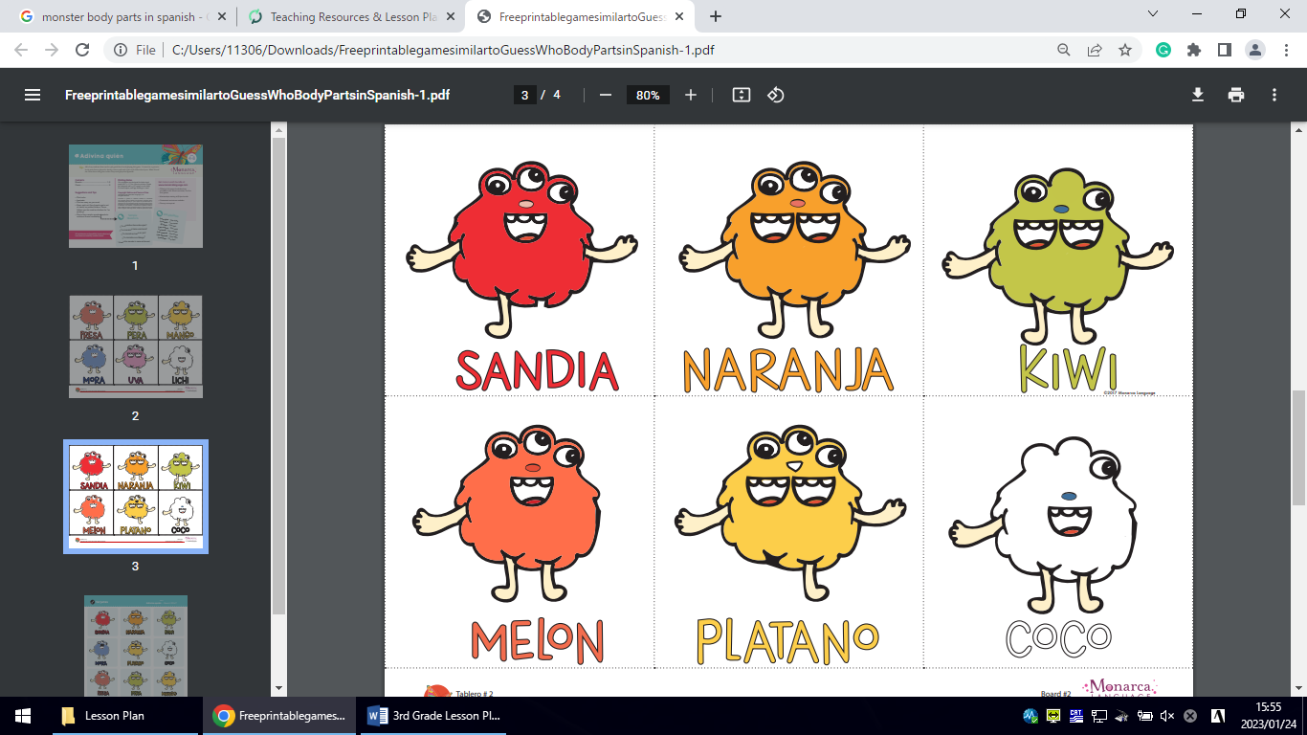

watermelon orange kiwi



Melon banana coconut