Who, Which & That
Shohei Ohtani is a person who can play baseball well.
used for people
Who
used for objects and animals
Which
Pizza is a famous food which is from Italy.

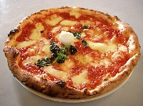

That
English is a language that is spoken around the world.

used for people, objects and animals

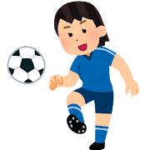
Round 1 – Who or Which (Not That)
- Soccer is the sport __________ we play with 11 team members.
- French fries are a food ___________ you can get from McDonalds.
- I want to be a person ___________ can sing English songs well.
- Do you have a friend ___________ lives in Fukuoka?
Round 2 – Guess the Answer (pairs)
- _____________________ is the famous Italian artist that painted the “Mona Lisa.”
- ____________________ is the Japanese hero who was born in a giant peach.
- _____________________ is the popular video website which was made in America.
Round 3 – Translate (pairs)
例）私たちは英語を話せる人が必要です。
We need a person that can speak English.
_______________________________________________________________________________.
- BTSは韓国出身のグループです。________________________________________________________________________________.
- Lineは日本で作られたアプリです。________________________________________________________________________________.

