Create a sales pitch for your product and present it in 1 minute.
- Name of your product
- What does it do?
- Who should buy it?
- Where can I buy this product?
- Cost of the product
Name of Product:
About Product:
Price:

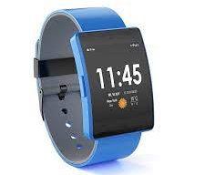
Wake Up

Are you tired of falling asleep in class? Are you tired of falling asleep when you have homework to do? Let us tell you about our product.
The name of our product is Wake Up. I think this product will be good for you. It is the perfect product for high school and university students. It is better than coffee.
I will tell you how it works. You wear it on your hand and when you are falling asleep it shocks you and wakes you up.
You can buy our product on Amazon and we will ship it to you.
The price for Wake Up is only ¥20,000. Please buy our product so you can stay awake in class.

Brainstorm

