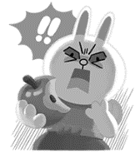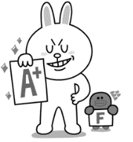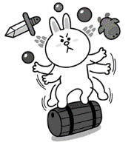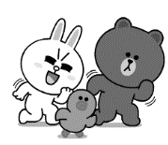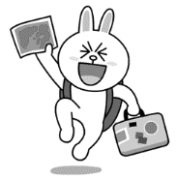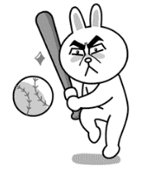

**Past Tense Dice Game**

**When you roll the dice you have to use the words below:**

1. yesterday
2. last week
3. two days ago
4. last month
5. two months ago
6. last year

**go to my friends house**

**Start**

**End**

**go to the park**

**do kendo**

**do sumo**

**want a book**

**go to the beach**

**free**

**want a bike**

**want more sleep**

**go to bed**

**eat ramen**

**free**

**drink milk**

**write a manga**

**study**

**drink tea**

**free**

**study science**

**drink water**

**play the piano**

**study English**

**study math**

**read a book**

**free**

**Free**

**write a blog**

**write a light novel**

**write a letter**

**write a book**

**play football**

**play soccer**

**play volleyball**

**eat an orange**

**Free**

**eat an apple**

**read a magazine**

**go to the library**

**eat pizza**

**eat bread**

**read a book**

**play baseball**

**go to school**