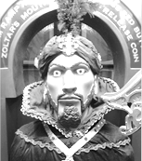

**Name: ________________**

**Zoltar**

**The**

**Fortune Teller**

**Name: __________**

**Answer: _________**

**Name: __________**

**Answer: _________**

1. **Which do you like ________ or ________?**

**I like ____________. (コイン: ________)**

**Name: __________**

**Answer: _________**

**Name: __________**

**Answer: _________**

1. **Which do you like ________ or ________?**

**I like ____________. (コイン: ________)**

**Name: __________**

**Answer: _________**

**Name: __________**

**Answer: _________**

1. **Which do you like ________ or ________?**

**I like ____________. (コイン: ________)**

**Gold コイン: ____ Silver コイン: ______**