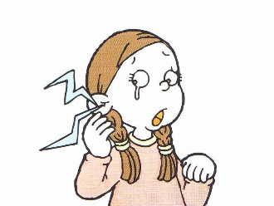

a stomachache

Name: _______________ Class: ____ Number: ___ Date: __/__

What’s wrong?

I have an earache.



|  |  |  |
| --- | --- | --- |
| Image result for cartoon headache  a headache | Image result for cartoon toothache  a toothache | Image result for cartoon stomach ache  a stomachache |
| Image result for cartoon backache  a backache | Image result for cartoon sore throat  a sore throat | Image result for cartoon fever  a fever |
| Image result for cartoon cough  a cough | Image result for cartoon runny nose  a runny nose | Image result for clipart broken heart  a broken heart |

**GIVING ADVICE**

1. For a fever you should _____________________________________________.
2. For a cut finger you should __________________________________________.
3. For a toothache you should __________________________________________.
4. For a stomachache you should _______________________________________.
5. For a broken leg you should _________________________________________.
6. For sore eyes you should ___________________________________________.
7. For a bad cough you should _________________________________________.
8. 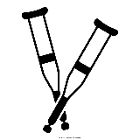For a broken heart you should _______________________________________.

**USEFUL WORDS**

The dentist

home

crutches

the hospital

bed

a band aid

medicine

a mask

eye drops