Hi, how are you?

I’m fine, thanks, and you?

I’m good, thanks.

Let’s play a quiz game!

Ok. I like games.

Four hints. One, it’s an object. Two, it’s black and white. Three, it’s heavy, I makes music.

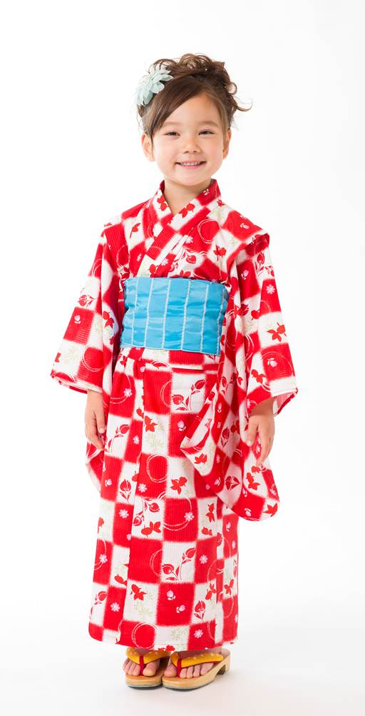
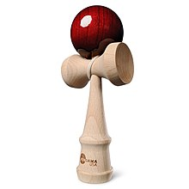
Hmmmm. Is it a piano?

Yes, you got it. Your turn.

Ok. One, it’s a fruit. Two, its red. Three, it’s small, Four, it’s sweet.

Hmmmm, it is a…

