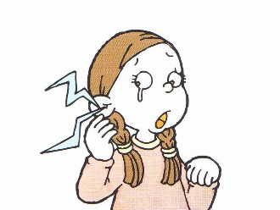
What’s wrong?
Doctor! Doctor!
Ouch! Ouch!
a stomachache
Name: _______________ Class: ____ Number: ___ Date: __/__
Yes, that’s right.
I see. Do you have an earache?
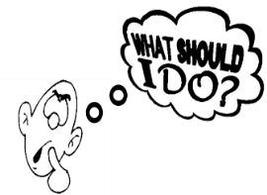
GIVING ADVICE
a headache  Sign: | 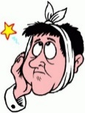  a toothache  Sign: | 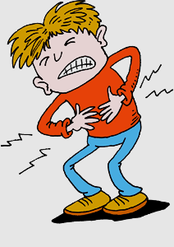  a stomachache  Sign:
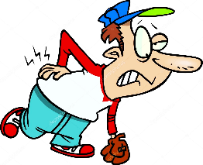  a backache  Sign: | 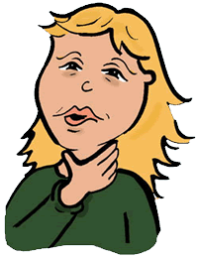  a sore throat  Sign: | a fever  Sign:
a cough  Sign: | a runny nose  Sign: | 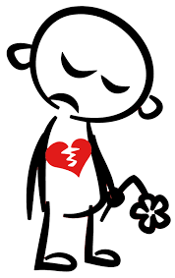  a broken heart  Sign:

- For a ______ you should ____________________________________________.
- For a cut _______ you should ________________________________________.
- For a __________ you should _______________________________________.
- For a ___________ you should ______________________________________.
- For a broken ______ you should ______________________________________.
- For sore ______ you should _________________________________________.
- For a bad ______ you should ________________________________________.
- For a ______ ______ you should _____________________________________.
USEFUL WORDS
medicine
a mask
eye drops
The dentist
home
crutches
the hospital
bed
a band aid

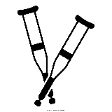
- What should I do for a fever?
- What should I do for a cut finger?
- What should I do for a toothache?
- What should I do for a stomachache?
- What should I do for a broken leg?
- What should I do for sore eyes?
- What should I do for a bad cough?
- What should I do for a broken heart?

