Name: ___________________ Class: _____ Number: ____ Date: ___/____
1年生SMALL TALK ONE

Wow!
Oh no!
How are you? | I’m fine. And you?
Do you like sushi? | Yes, I do. / No, I don’t.
What sports do you like? | I like tennis.
Can you cook? | Yes, I can. / No, I can’t.
What did you do on Sunday?  - How was it? | I ate… / I watched… / I played… / I went to…  - It was great.
Do you have any games?  - How many games do you have? | Yes, I do. / No, I don’t.  - I have a game. / I have many games.
When is your birthday?  - What do you want? | It’s…  - I want…
What do you want to do this year?  - What do you want to eat?  - What do you want to study?  Nice! | I want to…  - I want to eat…  - I want to study….
Have fun!
Me, too!
That’s great!
Wow!
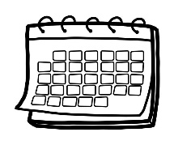 | 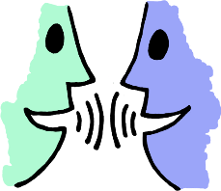 | 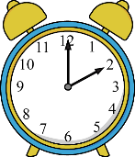 |  |  | 













