

You can eat anything in the picture

**Ship Wrecked**

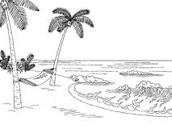

Mango Background clipart - Mango, Circle, transparent clip artMango Background clipart - Mango, Circle, transparent clip artMango Background clipart - Mango, Circle, transparent clip art

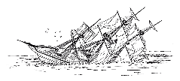Coconut Clipart Black And White, HD Png Download - kindpngCoconut Clipart Black And White, HD Png Download - kindpngCoconut Clipart Black And White, HD Png Download - kindpng

White Rabbit Easter Bunny Hare Clip art - Rabbit Cliparts png download -  480*597 - Free Transparent White Rabbit png Download. - Clip Art Library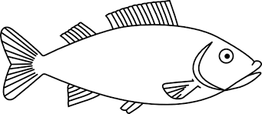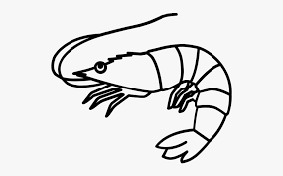

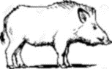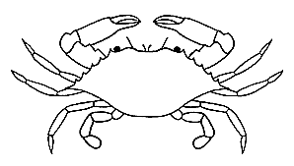

wild boar

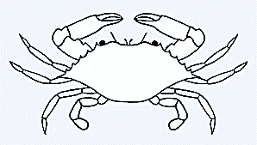

|  |  |  |
| --- | --- | --- |
| C:\Users\9692393\AppData\Local\Microsoft\Windows\INetCache\Content.MSO\A0E71791.tmpmatches | Plastic Bottle Coloring Page - Plastic Bottle Clipart Black And White, HD  Png Download - kindpnga water bottle | Swiss Army Knife SVG Pocket Knife Clipart Army Knife Files | Etsy | Swiss  army, Swiss army knife, Swiss army pocket knifea pocket knife |
| C:\Users\9692393\AppData\Local\Microsoft\Windows\INetCache\Content.MSO\9C17241C.tmpa sleeping bag | C:\Users\9692393\AppData\Local\Microsoft\Windows\INetCache\Content.MSO\402304F2.tmpa flash light | Download First Aid Kit Clipart Black And White PNG Image with No Background  - PNGkey.coma first aid kit |
| Free Plate Cliparts Black, Download Free Plate Cliparts Black png images,  Free ClipArts on Clipart Librarya plate | C:\Users\9692393\AppData\Local\Microsoft\Windows\INetCache\Content.MSO\D1A68BB.tmpa compass | Transparent Airplane Icon Png - Aeroplane Seat Icon, Png Download - kindpnga chair |
| Free Candy Bar Clipart Black And White, Download Free Candy Bar Clipart  Black And White png images, Free ClipArts on Clipart Librarya chocolate Bar | C:\Users\9692393\AppData\Local\Microsoft\Windows\INetCache\Content.MSO\76051EF1.tmprope | C:\Users\9692393\AppData\Local\Microsoft\Windows\INetCache\Content.MSO\680A14BA.tmpa guitar |
| Vector Black And White Stock Coloring Page Free Clip - Whistle Clipart Black  And White - 5583x3319 PNG Download - PNGkita whistle | Graphic Download Black And White Smartphone Clipart - Mobile Phone - Png  Download - Full Size Clipart (#921506) - PinCliparta Cell Phone | Hand with mirror stock illustration. Illustration of retro - 114591494a mirror |

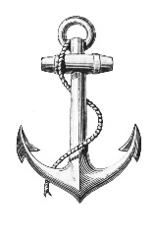What are you going to take? (Choose 3 things)

1_______________________________________________________________________________2_______________________________________________________________________________3_______________________________________________________________________________

What are you going to eat?

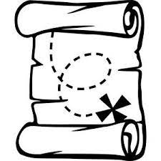1_______________________________________________________________________________________________________________________________________________________________2_______________________________________________________________________________ ________________________________________________________________________________

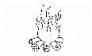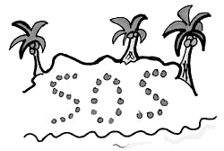

How are you going to escape? (Going to do)

