Which Doraemon character is this?

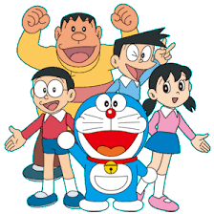

|  |  |
| --- | --- |
| English name | Japanese name |
| Noby |  |
| Big G |  |
| Sneech |  |
| Ace Goody |  |
| Sue Morris |  |
| Little G |  |