Snoopy wants to go to Japan for _____ weeks!

What does he want to do? Match the answers:

- go to | - Japan
- watch a | - friends
- drink | - kimono
- wear a | - Tokyo
- meet | - takoyaki stands
- ride | - okonomiyaki
- look for | - Kabuki show
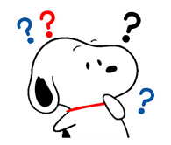  - eat | - Nagoya Castle
- see | - tea
- buy | - the shinkansen
- stay in | - souvenirs

Your turn! Where would you like to go if you had the time and money?

