Name：＿＿＿＿＿＿＿＿＿＿＿＿＿＿＿＿＿＿Class:______No.:_____Date:___________________
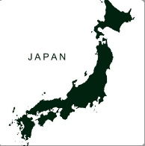
From Japan to the world

Student A: ‘’It is 6am in Japan. What time is it in Cape Town?’’
Student B: (-7hours) ‘’It is 12am in Cape Town.’’
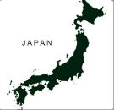
1. It is 9am in Japan.
It is _________am/pm in Cape Town, South Africa.

2. It is 10pm in Japan. It is________am/pm in Vancouver, Canada.

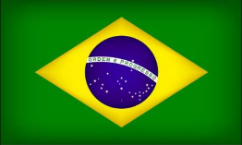
3. It is 6am in Japan. It is_________am/pm in Rio, Brazil.
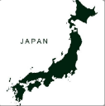

4. It is 12pm in Japan. It is_________am/pm in Nuuk, Greenland.

5. It is 7am in Japan. It is__________am/pm in Cairo, Egypt.

6. It is 4pm in Japan. It is_________am/pm in London ,England.

7. It is 4:30am in Japan. It is________am/pm in Beijing,China.

8. It is 1am in Japan. It is________am/pm in New Dehli,India.
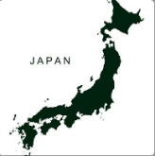

9. It is 3am in Japan. It is________am/pm in Auckland,New zeland.
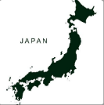
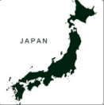
10. It is 4am in Japan.

It is__________am/pm in Sydney, Australia.

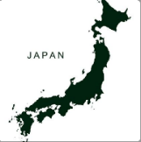
11. It is 13:30 in Japan.
It is____________am/pm in New York, USA.

