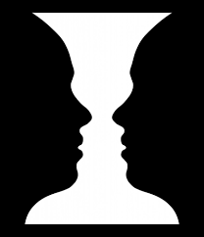
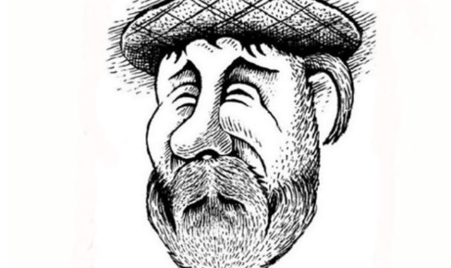
Optical Illusions
Example- I think that there is a vase.

- What color is the dress? (it is)
______________________________________________________________________
- Is the cat going up or down the stairs? (going)
______________________________________________________________________
- What animal is it? (it is a)
______________________________________________________________________
- Is the woman old or young? (she is)
______________________________________________________________________
- What animal is it? (it is)
______________________________________________________________________
- Is it a man or a dog? (it is a)
______________________________________________________________________
- What animal is it? (it is a)
______________________________________________________________________
- Is the bus going left, or right? (it is going)
______________________________________________________________________
- How many legs does the elephant have? (it has)
______________________________________________________________________

