Name: ___________________ Class: ______ Number: _______ Date: __/__
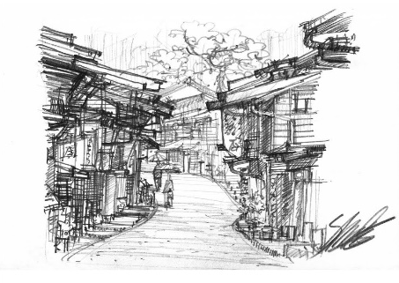
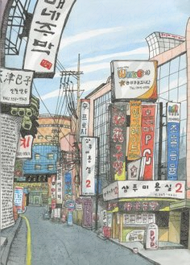
MY
HOME
TOWN
例:When you visit my hometown, please go to the Sleeping Giant Park. If you go there, you can enjoy camping and hiking. The lake is very beautiful.

