Your ships
 | sofa | piano | table  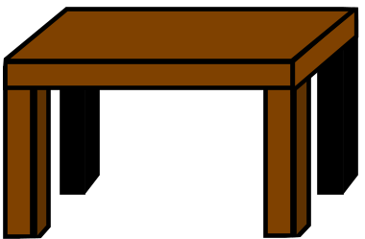 | box
by

1 space 2 spaces 3 spaces
Your friend’s ships
 | sofa | piano | table | box
by

A: Where is it?
It is ___ the _____.
A: Yes, it is. / No, it isn’t.

